May 1st, 2022

Ref: Notification of Updates to Distribution
Change of Vendor of Record

To Whom It May Concern:

With an effective date of May 1st, 2022, Batiscafo S.L. has appointed Spanish Publishers, LLC. as the exclusive distributor for the United States for all books published by them.

Batiscafo S.L. is a distributor that has the representation for the United States of the following imprints: Alamut (Artifex Bibliópolis), Impedimenta, Libros del Asteroides, Nórdica, and Galaxia Gutenberg.

Please change your vendor of record for orders, returns and payments to reflect this change.

Please see the attached file with prefixes for all the publisher’s prefixes.

Sincerely,
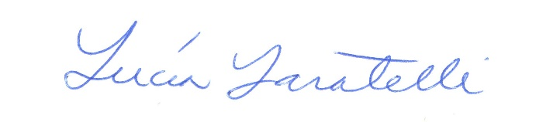

Lucia Laratelli
President of Spanish Publishers, LLC.

