Children’s Books Day Workshop
Encuentro del Libro Infantil

Listado de asistentes
Apellidos | Nombre | Email | Institución / Posición
Alba Cascales | Rafael | rafael.albac@gmail.com | Murchison MS
Anderson | Linda
Anderson | Minda | minda.l.anderson@austinisd.org | Becker Elementary-Austin ISD
Arbino | Daniel | d.arbino@austin.utexas.edu | Benson Latin American Collection-UT
Arroyo | Chiara | chiara@la-librería.net | La Librería
Billeaud | Genifer | genifer.billeaud@esc13.txed.net
Brown | Darla | Darla.Brown@leanderisd.org | Leander ISD
Candelas | Javier | jcandelas@legacypca.com | Legacy Preparatory Charter Academy
Carmen Del Canto | Ana | AnaCarmen.DelCanto@esc13.txed.net | Oficina Educación
Carvajal | Elena | elena@westbanklibrary.com
Cervantes | Michelle | mcervantes@roundrocktexas.gov
Clari Rubio | Mª Dolores Raquel | mclarir@uoc.edu | Hornsby-Dunlap E.S.
Correa | Alex | acorrea@lectorum.com | Lectorum
Crumhorn | Laura | laura.crumhorn@austinisd.org | Ridgetop Elementary
de Jongh | Daniela | cuentologybox@gmail.com | Cuentology Books
Díaz | Mariela | mariela@spanishpublishers.net | Spanish publishers LLC
Douglass | Marie | marie_douglass@roundrockisd.org | Round Rock ISD
Dusing | Brad | bradley.dusing@austinisd.org | Sunset Valley Elemetary
Farro | Edith | e.farro@chulainnlibros.com | Chulainn
Ferate Soto | Paola | Paola.Ferate-Soto@austintexas.gov
Galan Martin | Marta | marta.galanmartin@austinisd.org | Menchaca Elementary
Galindo | Claudine | galindoc@cfbisd.edu | C-FB ISD
Galindo | Jacqueline | galindoj@cfbisd.edu | C-FB ISD
Gallego Pulido | David | davidgp19@hotmail.com | AISD
García | Daniela | danglannoy@gmail.com
Garcia-Mota Martinez | Vanessa | vgmota.psi@gmail.com | Brentwood Elementary - Kinder Bilingue
Garza | Liliana | liliana.garza@magellanschool.org | Magellan International Schools
Garza de Cortés | Oralia | oraliagarzacortes@gmail.com
Graham | Denise | denise.graham@austinisd.org | Elizabeth Polk Library at  Uphaus ECC
Grautly | Alice | alicegraulty@gmail.com
Hartman | Angela | angela.hartman@huttoisd.net | Hutto ISD
Hoyles | Troy | troy.hoyles@sanantonio.gov | San Antonio Library
Iciar Alcalde | Maria | ici@iciar.info
Jimenez | Lucas | ljimenez@legacypca.com | Legacy Preparatory Charter Academy
Jimenez | Ruben | rubenjsanz@gmail.com | Oak Meadows Elementary
Lasky | Monica | Monica.Lasky@leanderisd.org | Leander ISD
Lazo | Carmen | carmenl@pflugervilletx.gov
Leyva | Christina | christina_leyva@roundrockisd.org | Robertson Elementary School
Lois-Borzi | Ana | loisborzi@gmail.com | Austin Waldorf School
López Rosdahl | Nohemi | Nohemi.rosdahl@sanantonio.gov | San Antonio Library
Magana-Noverola | Irene | Irene.Magana-Noverola@austintexas.gov
Marschall | Emma | emma.marschall@austintexas.gov
Martínez Howard | Liliana | liliana.howard@austinisd.org | T.A. Brown E.S
Meredith | Mary | marymeredith@stephenvilletx.gov | Stephenville Public Library
Mikeska | Elizabeth | elizabeth.mikeska-benfield@austinisd.org
Miranda-Murillo | Diana | Diana.Miranda-Murillo@austintexas.gov | Austin Public Library
Morrison | Alexandra | alexandra.morrison@austinisd.org | Austin ISD
Pack Zia | Angela | thinkbilingual@gmail.com
Paredes-Gonzalez | Yvette | yvette.gonzales@mvisd.org | Medina Valley ISD
Passariello | Aileen | aileen@mama-lingua.com | Mama Lingua
Paulino | Cathy | cathypaulino@stephenvilletx.gov | Stephenville Public Library
Pérez | Olivia | perezo@cfbisd.edu | Director of Bilingual/ESL
Razo | Teresa | teresa_razo2003@yahoo.com | Austin ISD
Reta | Maria | maria.retaortiz@austinisd.org | Metz Elementary
Reyes | Aida | reyesa@cfbisd.edu | C-FB ISD
Robledo | Mariana | mariana.robledo@austinisd.org | Menchaca Elementary
Rocco | Marion | marion.rocco@austinisd.org | Austin ISD
Rodríguez | Jesca | jessica.i.rodriguez@austinisd.org | Menchaca Elementary
Rodríguez | José Ramón | jrlago@telefónica.es | Murchison MS
Rosas-Ortega | Lucero | lucero.rosas-ortega@mvisd.org | Potranco Elementary
Rukovena | Lisa | Lisa.Rukovena@esc13.txed.net | ESC13
Salcido | Bryana | bryana.salcido@austintexas.gov
Shumaker | Rebeccah | rebeccah@loritobooks.com | Lorito Books
Surbeck | Susana | susana.surbek@hotmail.com | French School of Austin
Urbina | Heidy | heidy.urbina@austintexas.gov
Uyarra-Salcido | Rosa
Van De Hoef | Grace | gav25@txstate.edu | Texas State University
Van De Hoef | Joy | joy.vandehoef@esc13.txed.net | Region 13
Vaso | María | Maria.Garcia-vasocanova@leanderisd.org | Leander ISD
Vazquez | Cynthia | cynthia.vasquez@mvisd.org | Castroville Elementary
Vergara | Norma | nvergara@ci.pasadena.tx.us | Pasadena Public Library
Wayne | Kelsey | kwayne@ipgbook.com | IPG
Wise | Melissa | melissa.wisse@austintexas.gov

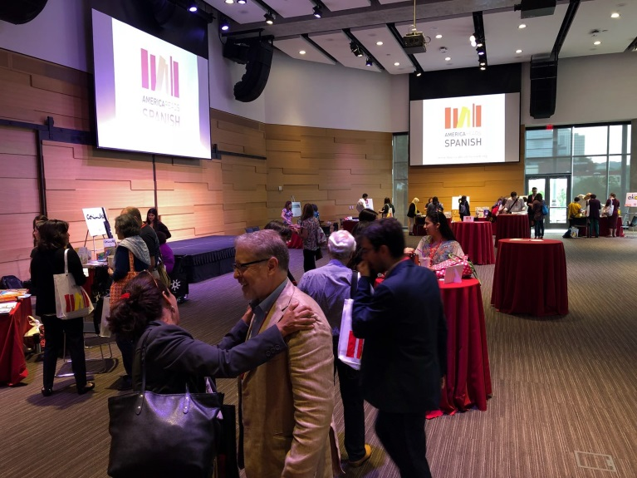 | 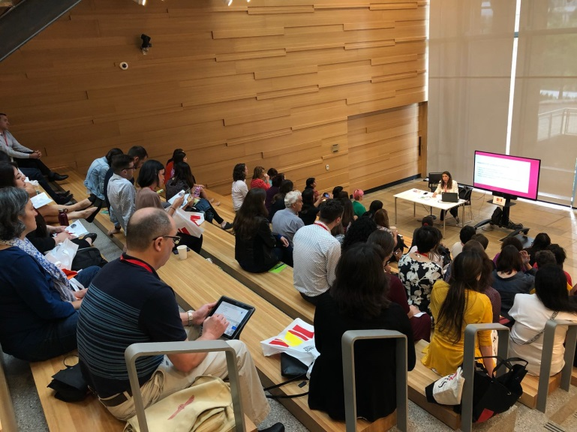
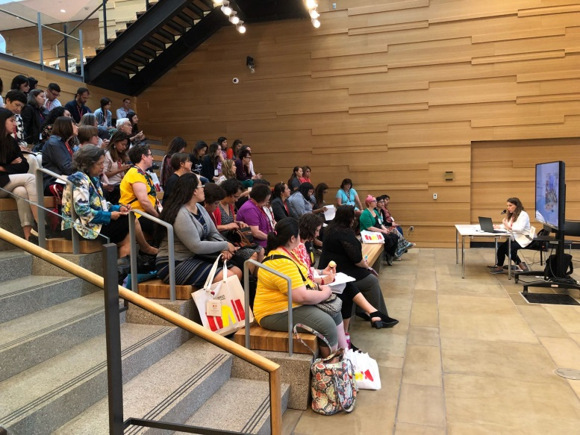 | 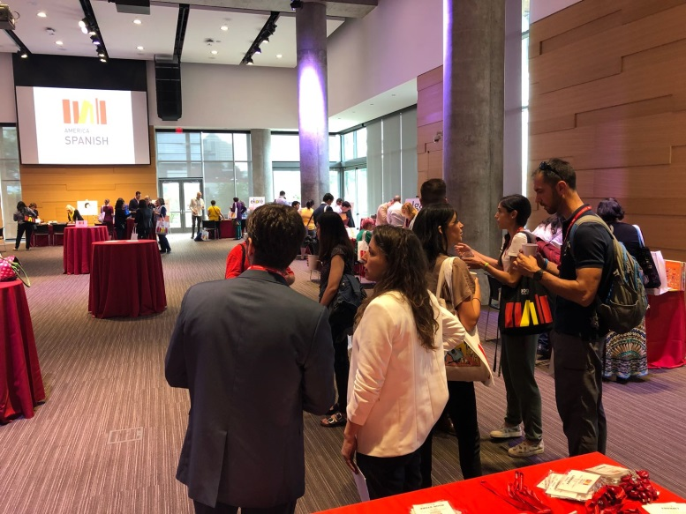
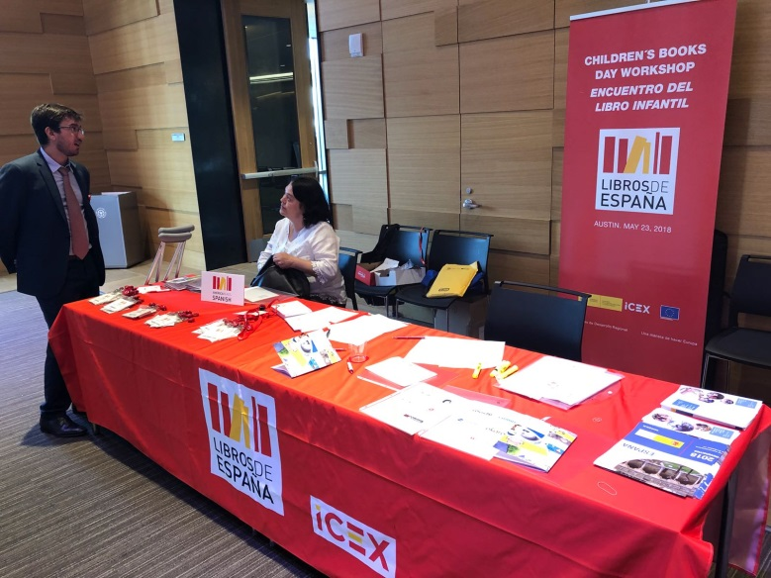 | 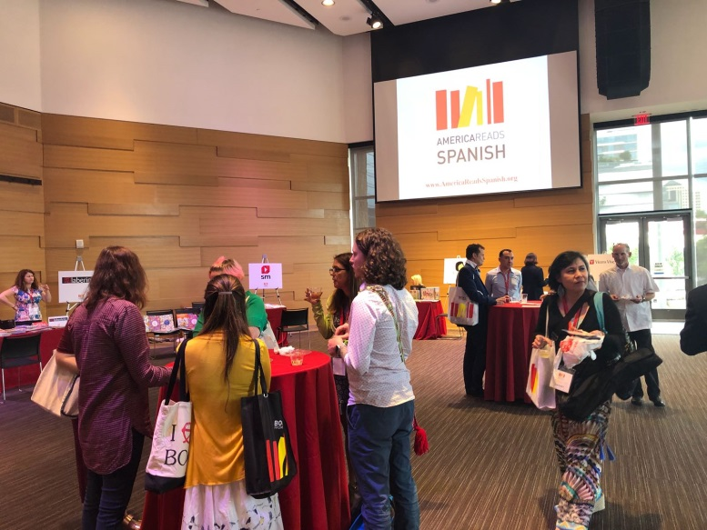

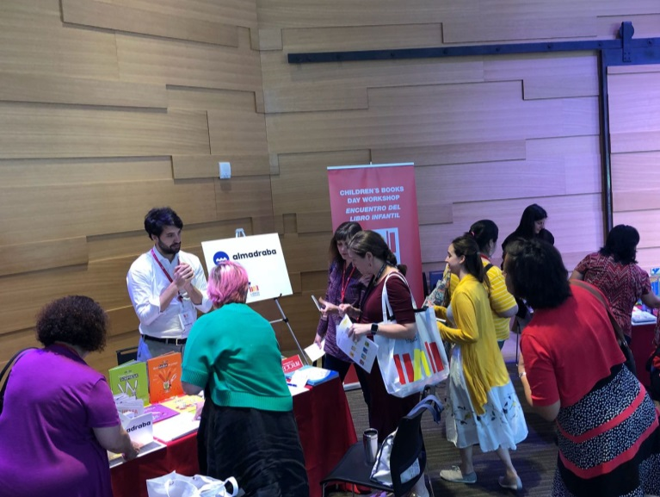 | 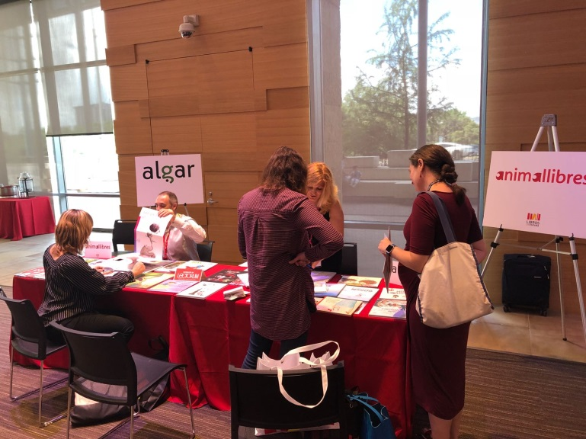
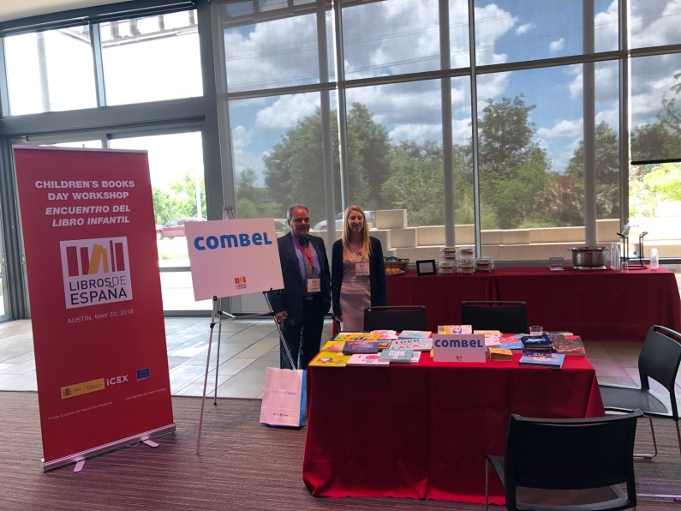 | 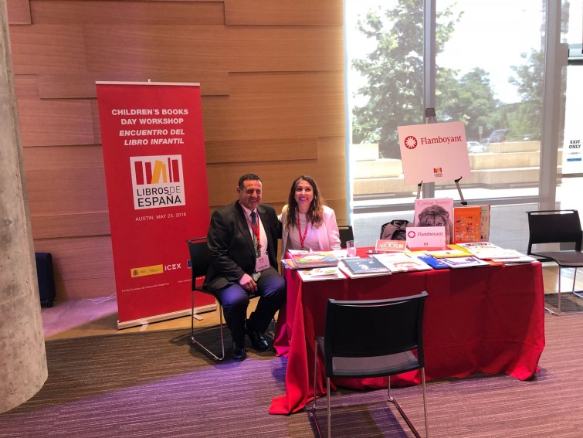
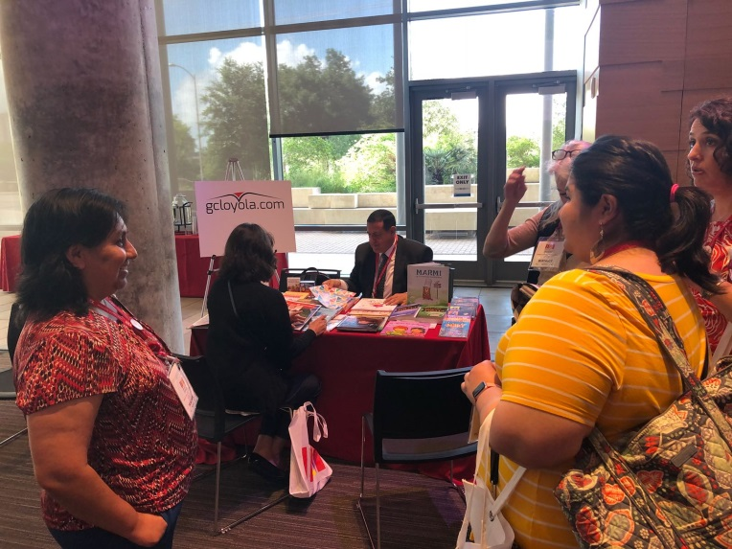 | 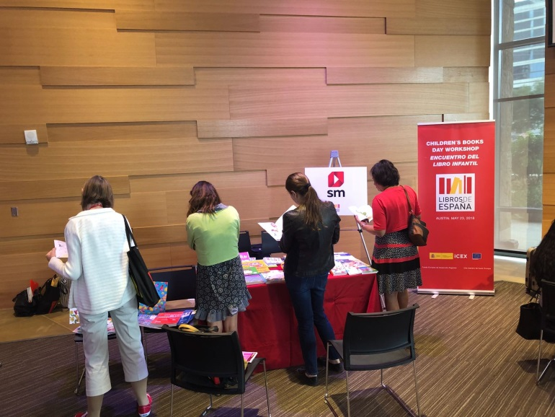

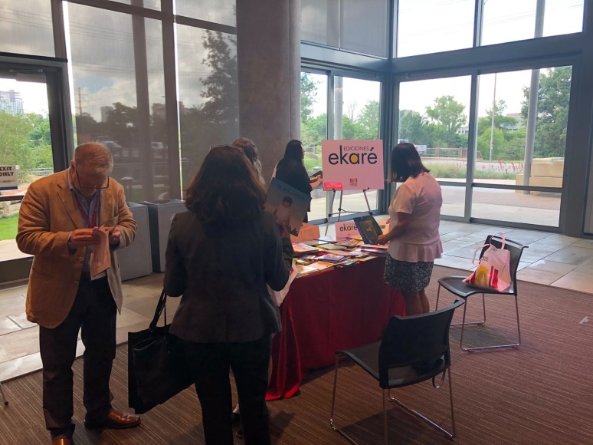 | 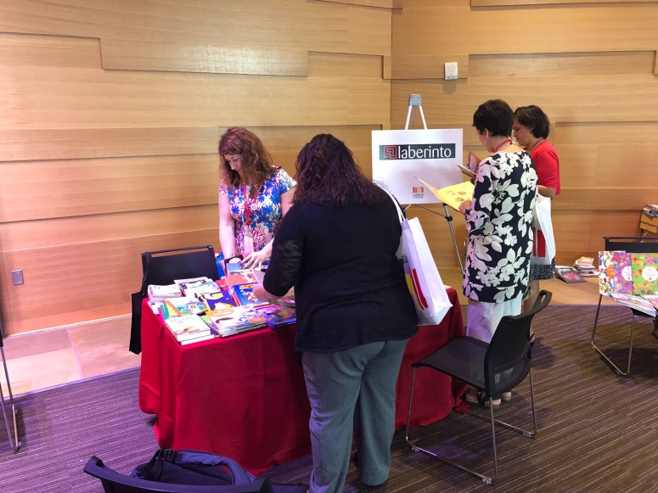
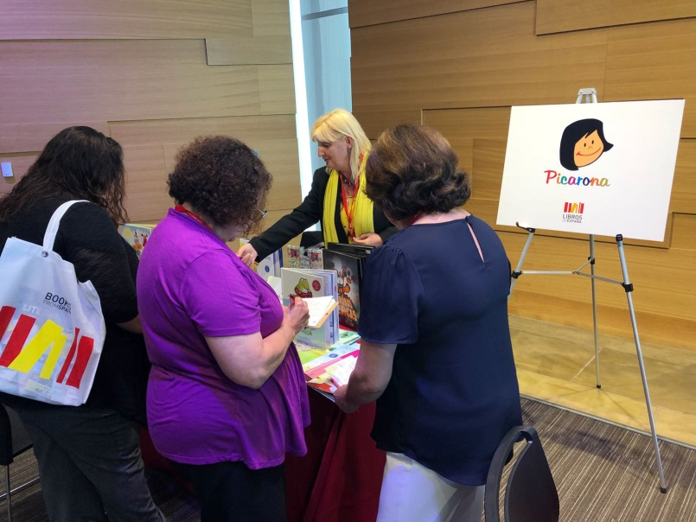 | 