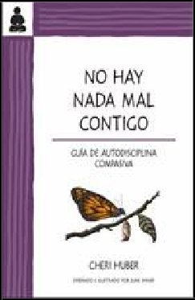

Keep It Simple Books 9780991596348
Pub Date: 10/15/18
On Sale Date: 10/15/18 Ship Date: 10/1/17
$12.00/$14.95 Can.
Discount Code: LON Trade Paperback
250 Pages
Carton Qty: 40 Religion / Buddhism REL092000
8.5 in H | 5.5 in W

No hay nada mal contigo

Guía de autodisciplina compasiva
Cheri Huber

Summary This book reveals the origin of self-hate, how self-hate works, how to identify it, and how to go beyond it. It provides examples of some of the forms self-hate takes, including taking blame but not credit, holding grudges, and trying to be perfect, and explores the many facets of self-hate, including its role in addiction, the battering cycle, and the illusion of control. After addressing these factors, it illustrates how a meditation practice can be developed and practiced in efforts to free oneself from self-hating beliefs.
Contributor Bio Cheri Huber has been a student and teacher of Zen for over 35 years and is the founder of the Zen Monastery Peace Center and Living Compassion, a nonprofit dedicated to peace and service. She is also the author of 20 books including The Big Bamboozle and What You Practice Is What You Have.

IPG

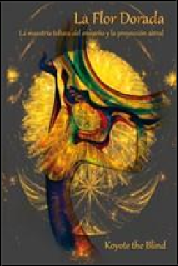

Gateways Books & Tapes 9780895562814
Pub Date: 10/12/18 Ship Date: 5/1/18
$19.95/$26.95 Can.
Discount Code: LON Trade Paperback
172 Pages
Carton Qty: 20
Body, Mind & Spirit / Dreams
OCC006000
Series: Consciousness Classics
9 in H | 6 in W

La Flor Dorada

La maestría tolteca del ensueño y la proyección astral
Koyote the Blind

Summary A unique book on the art of dreaming, astral projection, and voyaging through the higher planes, presented by a Toltec shaman and Western magician. This is the Yoga of Dreaming. It is a distillation of the deepest teachings and art of lucid dreaming, delivered in clear and practical, yet poetic, prose. A delight to read, and filled with practical gems throughout. The exercises included in the text will introduce the novice to lucid dreaming practices—or enable the more advanced reader to experiment new approaches to Dreaming as a spiritual practice.
Contributor Bio Koyote the Blind runs Xicoco, an esoteric school of the Toltecs, where he trains students in magick, shamanism, mysticism, and yoga. He has created seminars on the Yoga of Dreaming, meditation, astral voyaging, shadow walking, magick, the power of attention, alchemy, and tantra. He lives in Riverside, California.

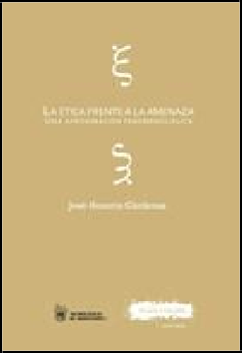

Plaza y Valdes 9788416032587
Pub Date: 10/1/18
$18.99/€23.46 EU
Discount Code: LON Trade Paperback
238 Pages
Carton Qty: 0
Philosophy / Ethics & Moral Philosophy
PHI005000
Series: Tecnológico de Monterrey
8 in H | 5.8 in W

La ética frente a la amenaza

Una aproximación fenomenológica
José Honorio Cárdenas

Summary A threat is a form of violence?a personal, non-transferrable experience that inherently affects a person’s life and relationships. Taking a phenomenological approach, this thought-provoking book reflects on the experience of victims of threats while attempting to rouse the reader’s empathy towards them and their plight.
Contributor Bio José Honorio Cárdenas Vidaurri is a researcher, professor, scholar, and the dean of the School of Higher Education and Humanities at Monterrey University. He holds doctorate and master’s degrees in philosophy, education, humanities, and family counseling.

IPG

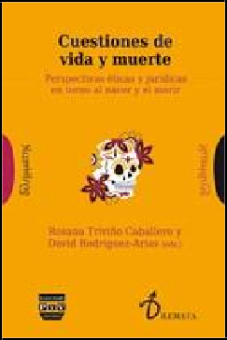

Plaza y Valdes 9788416032716
Pub Date: 10/1/18
$22.00/€27.66 EU
Discount Code: LON Trade Paperback
284 Pages
Carton Qty: 0 Philosophy / Social PHI034000
Series: Dilemata
9.5 in H | 6.3 in W

Cuestiones de vida y muerte

Perspectivas éticas y jurídicas en torno al nacer y el morir
David Rodríguez-Arias, Rosa Triviño Caballero

Summary In the face of life and death becoming increasingly controlled, mediated events, a fruitful discussion marked by diverse attitudes and opinions provides the framework for this profound bioethical reflection on the social processes involved at the beginning and end of life.
Contributor Bio David Rodríguez-Arias is a researcher at Granada University and specializes in bioethics and global justice. He holds a PhD in moral philosophy and medical ethics from the University of Salamanca and the University of Paris-Descartes. He has co-authored and co-edited several articles and books. Rosana Triviño Caballero is a researcher, scholar, and author. She holds a PhD in moral philosophy from Salamanca University as well as degrees in political philosophy, humanities, and political science and constitutional law. She is the author of the book El peso de la conciencia.

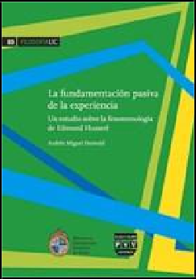
Plaza y Valdes 9788416032747
Pub Date: 10/1/18
$17.95/€22.06 EU
Discount Code: LON Trade Paperback
258 Pages
Carton Qty: 0
Philosophy / Movements PHI018000
Series: Filosofía UC
8.3 in H | 5.8 in W

La Fundamentación pasiva de la experiencia

Un estudio sobre la fenomenología de Edmund Husserl
Andrés Miguel Osswald

Summary By providing genetic and generativist perspectives on phenomenology developed in the 1920s and 1930s, this well-researched book intends to broaden the debate between the descriptive and the transcendental approaches to phenomenology. It also provides a well-rounded description of subjectivity in Husserl’s philosophy.
Contributor Bio Andrés Miguel Osswald is a university professor and researcher with a PhD in philosophy from the University of Buenos Aires. He is an editor at Idea, a magazine specialized in modern and contemporary philosophy, and his articles have been featured in various journals. He has also contributed chapters to edited books.

IPG

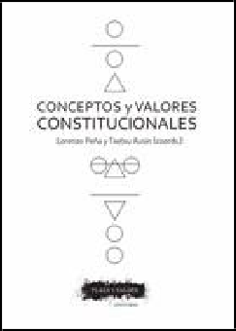

Plaza y Valdes 9788416032952
Pub Date: 10/1/18
$22.00/€27.66 EU
Discount Code: LON Trade Paperback
402 Pages
Carton Qty: 0
Law / Jurisprudence LAW052000
8 in H | 5.8 in W

Conceptos y valores constitucionales
Txetxu Ausín, Lorenzo Peña

Summary The essays collected in this comprehensive volume present the views of several experts about constitution from a variety of radically diverse?and sometimes opposing?doctrinal perspectives. The book also addresses related matters such as the connection between popular sovereignty and supranational institutions, and the link between freedom and equality.
Contributor Bio Txetxu Ausín is a professor, researcher, and scholar. He holds a PhD in philosophy from the University of the Basque Country. He has co-authored many books, including Pasando fronteras and Los derechos positivos.Lorenzo Peña is a philosopher, scholar, and researcher. A member of the Bar Association of Madrid, he holds doctorate degrees in philosophy and law. He is the author or co-author of many books, including Estudios republicanos and Visión lógica del derecho

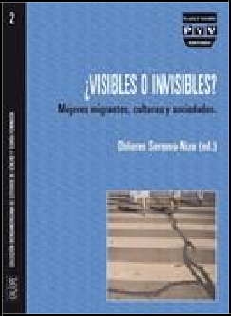

Plaza y Valdes 9788492751365
Pub Date: 10/1/18
$21.95/€26.26 EU
Discount Code: LON Trade Paperback
200 Pages
Carton Qty: 1000
Social Science / Feminism & Feminist Theory SOC010000
9.3 in H | 6.8 in W

¿Visibles o invisibles?

Mujeres migrantes, culturas y sociedades
Dolores Serrano-Niza

Summary A new cultural framework is developing around the question of women and migration. This reflective collection of accessible and interdisciplinary essays attempts to analyze this scenario by breaking the matter into two major areas: one focusing on ethics, sociology, and culture, the other one tackling gender and Islam.

Las mujeres y las migraciones conforman en nuestra sociedad actual un binomio conceptual firme. En esta obra se quiere analizar el nuevo entramado cultural que se está gestando en lo que, parece ser, un orden social diferente. En este existe un pensamiento y un lenguaje particular en el que se da cabida, entre otros, a desacostumbradas combinaciones de palabras partiendo de transnacional, ahora acompañada de feminismo, familias o madres. Al hilo de este asunto aparecerán otros conceptos: el de la visibilidad y el de la invisibilidad. La visibilidad sobredimensionada y sustantiva marcada por esos pañuelos que visten las musulmanas junto a la invisibilidad que supone el trabajo doméstico o la ausencia de derechos que afecta a tantas mujeres. ¿Visibles o invisibles? Mujere...
Contributor Bio Dolores Serrano-Niza is an award-winning researcher, scholar, and author. She holds a PhD in Arabic philology and is a professor of Arabic and Islamic studies. She coordinated and coauthored the award-winning collection Mujeres y religiones.

IPG

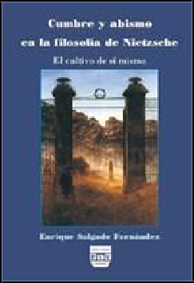

Plaza y Valdes 9788496780064
Pub Date: 10/1/18
$29.00/€35.39 EU
Discount Code: LON Trade Paperback
432 Pages
Carton Qty: 1000 Philosophy / Movements PHI006000
9.3 in H | 6.8 in W

Cumbre y abismo en la filosofía de Nietzsche

El cultivo de sí mismo
Enrique Salgado Fernández

Summary Living creatively is the Nietzschean answer to the challenges of nihilism. In other words, knowing how to live means knowing how to cultivate oneself and how to transform one’s own life into a creation. This examination into Nietzsche’s answer to nihilism is divided into two sections which correspond to the concepts of the abyss and the summit, so intimately intertwined in Nietzsche’s philosophy.
Contributor Bio
Enrique Salgado Fernández holds a PhD in philosophy from the National University for Distance Learning. He is a member of the editorial board at Cuadernos del Matemático magazine, to which he has contributed many literary and philosophical writings.

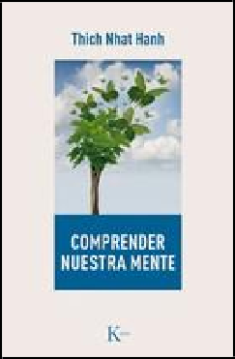

Editorial Kairos 9788499885728
Pub Date: 10/1/18
$27.95
Discount Code: LON Trade Paperback
384 Pages
Carton Qty: 36 Religion / Buddhism REL007000
8 in H | 5 in W | 0.9 in T |
0.9 lb Wt

Comprender nuestra mente
Thich Nhat Hanh

Summary In Comprender nuestra mente, the Vietnamese Buddhist master Thich Nhat Hanh provides a thorough introduction to Buddhist philosophy. Based on 50 famous verses about nature by Vasubandhu, he demonstrates the importance of these classic Buddhist teachings for life in the modern world.
Contributor Bio Thich Nhat Hanh is a Buddhist monk and teacher, a poet, a peace activist, and the author of Be Free Where You Are, The Miracle of Mindfulness, and Peace Is Every Step. He was nominated for the Nobel Peace Prize by Martin Luther King Jr. in 1967.

IPG

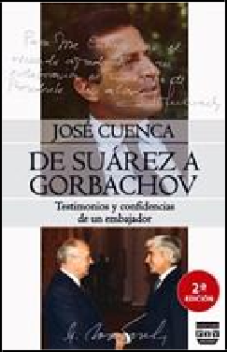

Plaza y Valdes 9788416032617
Pub Date: 10/1/18
$23.95/€29.07 EU
Discount Code: LON Trade Paperback
376 Pages
Carton Qty: 1000 History / Europe HIS010000
9.5 in H | 6.5 in W

De Suárez a Gorbachov

Testimonios y confidencias de un embajador
José Cuenca

Summary With his usual expertise and compelling tone, Mr. Cuenca offers an invaluable testimony on three decisive diplomatic events in the history of Spain and international relations in the 20th century: foreign policy during the Spanish transition to democracy, Spain’s incorporation to the Atlantic Alliance, and the end of the Soviet Union.
Contributor Bio José Cuenca is a politician, diplomat, and writer. He has served as the Spanish ambassador in Bulgaria, the Soviet Union, Greece, and Canada. He is the author of many books, including La sierra caliente, La noche de bodas and Encuentros de un embajador con don Quijote.

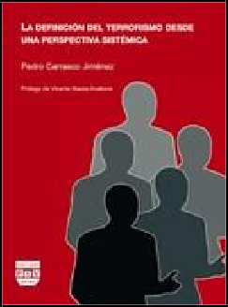

Plaza y Valdes 9788496780828
Pub Date: 10/1/18
$25.95/€31.17 EU
Discount Code: LON Trade Paperback
380 Pages
Carton Qty: 1000
Political Science / Terrorism POL037000
9.3 in H | 6.8 in W

La definición del terrorismo desde una perspectiva sistémica
Pedro Carrasco Jiménez

Summary One person’s terrorist is another’s freedom fighter. This is the—apparently unsolvable—dilemma that arises in discussions about the nature of terrorism. Surprisingly, this uncertainty has not impeded the Global War on Terrorism, in which every citizen has been reduced to a potential terrorist. This book addresses questions such as: What is the difference between political activism and terrorism? When does counterterrorism become state terrorism? As a result, the book presents a definition of terrorism from the perspective of systems theory that centers on civil rights and political liberties.
Contributor Bio Pedro Carrasco Jiménez is a former lawyer with a background in global security and defense. He has published articles in various specialized journals and has participated in numerous congresses.

IPG

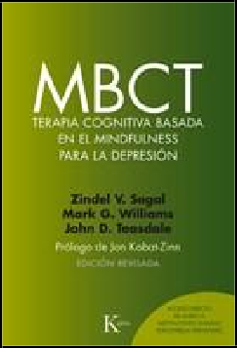

Editorial Kairos 9788499885674
Pub Date: 10/1/18
$44.95/€42.39 EU
Discount Code: LON Trade Paperback
639 Pages
Carton Qty: 16 Psychology / Cognitive Psychology & Cognition PSY008000
9 in H | 6 in W | 1.4 in T | 2 lb Wt

MBCT Terapia cognitiva basada en el mindfulness para la depresión
Zindel V. Segal, John D. Teasdale, Mark G. William...

Summary Learn how to integrate meditation, mindful movement, and cognitive interventions into each of a set of group sessions. Participants learn to distance themselves from automatic bodily and mental processes that appear with depression. This book also serves as a clinical guide for mindfulness practice and a guide to the latest research about the effectiveness of MBCT.

Contributor Bio
Zindel V. Segal is a professor emeritus of the psychology of mood disorders at the University of Toronto. John D. Teasdale is an honorary professor at the United Kingdom Medical Research Council’s Cognition and Brain Sciences Unit. Mark G. Williams is a professor of clinical psychology and an adjunct researcher at the University of Oxford. He is the director of the Oxford Mindfulness Center.

Ediciones Rodeno 9788494670992
Pub Date: 10/1/18
$25.95
Discount Code: LON Hardcover
104 Pages
Carton Qty: 26
Ages 7 to 9, Grades 2 to 4 Juvenile Fiction / Animals JUV002000
Series: Fotografía de Naturaleza
7.3 in H | 9.8 in W | 0.5 in T
| 1.1 lb Wt

Érase un ratón

Cuentos de un fotógrafo de naturaleza
Ramiro Díaz

Summary Foxes, wolves, toads, mice, and also dragons… many animals inhabit the stories of our collective imaginations. Some animals can be nice, but they aren’t all stuffed animals either. This work tries to create a new way of seeing these animals from the perspective of a photographer who mixes fantasy with nature.
Contributor Bio
Ramiro Díaz is a marketing director and a photographer. He previously collaborated on the books Con ojos de gato and Naturaleza en color.

IPG

Combel Editorial 9788491012894
Pub Date: 10/1/18
$18.95
Discount Code: LON Hardcover
16 Pages
Carton Qty: 16
Ages 3 to 5, Grades P to K Juvenile Fiction / Classics JUV007000
7.3 in H | 7.3 in W | 1 in T |
1.1 lb Wt

Blancanieves
Xavier Deneux

Summary A new adaptation of the classic story of Snow White in an embellished design. This book is part of a thoughtful collection for kids that helps them discover a unique way of interacting with classic tales.
Contributor Bio Nacido en Francia, este ilustrador goza de un merecido prestigio gracias a los numerosos libros que ha ilustrado. Se especializa en obras concebidas para bebés y para niños en edad preescolar.

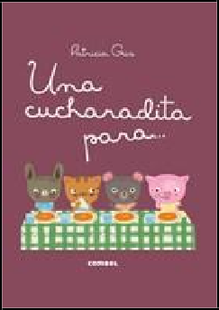

Combel Editorial 9788491012566
Pub Date: 10/1/18
$14.95
Discount Code: LON Hardcover
12 Pages
Carton Qty: 32
Ages 0 to 3, Grades P to K Juvenile Fiction / Health & Daily Living
JUV015010
Series: Los Dudús
7.3 in H | 10 in W | 0.9 in T
| 0.8 lb Wt

Una cucharadita para...
Patricia Geis

Summary The Dudus have spent the day in the park, and now it's time to go home and clean up. Young readers will follow Conejo, Chanchita, Miu, and Osito through different daily activities in order to learn a routine of personal health.
Contributor Bio Patricia Geis studied graphic design at EINA University in Barcelona and graduated with a BA from the New York Institute of Technology. She is the author of more than forty children's books.

IPG

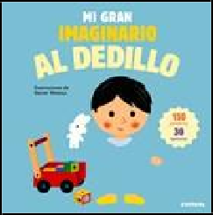

Combel Editorial 9788491012764
Pub Date: 10/1/18
$22.95
Discount Code: LON Board Book
22 Pages
Carton Qty: 14
Ages 0 to 3, Grades P And Under
Juvenile Fiction / Concepts JUV009080
9.8 in H | 9.8 in W | 1 in T |
1.5 lb Wt

Mi gran imaginario al dedillo
Xavier Deneux

Summary A small learning encyclopedia to help toddlers discover the world around them. With more than thirty textures and 150 words, plus a playful and interactive educational design, this book will help young ones learn and develop their vocabulary.
Contributor Bio Xavier Deneux has garnered special recognition for many of the books he has illustrated. He specializes in stories for babies to pre-school-age kids.

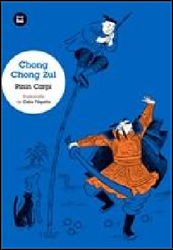
Bambú 9788483435090
Pub Date: 10/1/18
$9.95
Discount Code: LON Trade Paperback
272 Pages
Carton Qty: 28
Ages 9 to 12, Grades 4 to 7 Juvenile Fiction / Action & Adventure
JUV001000
Series: Jóvenes lectores
8.3 in H | 5.8 in W | 0.7 in T
| 0.9 lb Wt

Chong Chong Zul
Pinin Carpi

Summary Chong Chong Zul has a blue cat, an orange dog, and a little fish named Zul. One night, the snow covers Chong Chong Zul's orange dog in white flakes. This gives him an idea: Orange ice cream! He travels to the market to buy some, and along the way he meets the emperor Wei Ming with whom he begins a fantastic adventure. Chong Chong Zul is modern Italian children's classic, translated into Spanish for the first time.
Contributor Bio Pinin Carpi was a prolific Italian writer, illustrator, and poet. He won the Premio Cento for Italian literature in 1992. Chong Chong Zul is his first book.

IPG

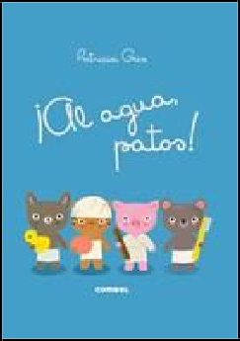

Combel Editorial 9788491012580
Pub Date: 10/1/18
$14.95
Discount Code: LON Hardcover
12 Pages
Carton Qty: 32
Ages 0 to 3, Grades P And Under
Juvenile Fiction / Health & Daily Living
JUV015010
Series: Los Dudús
7.3 in H | 10 in W | 0.7 in T
| 0.9 lb Wt

¡Al agua, patos!
Patricia Geis

Summary The Dudus have spent the day in the park, and now it's time to go home and clean up. Young readers will follow Conejo, Chanchita, Miu, and Osito through different daily activities in order to learn a routine of personal health.
Contributor Bio Patricia Geis studied graphic design at EINA University in Barcelona and graduated with a BA from the New York Institute of Technology. She is the author of more than forty children's books and has been published in Spain, France, the UK, the USA, Korea, and beyond.

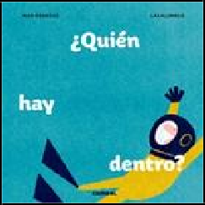

Combel Editorial 9788491012627
Pub Date: 10/1/18
$14.95
Discount Code: LON Hardcover
12 Pages
Carton Qty: 20
Ages 3 to 5, Grades P to K Juvenile Fiction / Animals JUV002000
Series: La cereza
9.3 in H | 9.3 in W | 0.5 in T
| 0.9 lb Wt

¿Quién hay dentro?
Mar Benegas

Summary Mystery, surprise, and fear! This book is a game which asks children to guess and describe the curious animals hidden behind the flaps on each page. There are surprises all the way to the end, but only the bravest will make it.
Contributor Bio Mar Benegas is a poet, writer, and author of children’s books. She is the coordinator of children’s poetry for the children’s literature non-profit, Atrapavientos, and has led numerous creative workshops and projects across Spain.

IPG

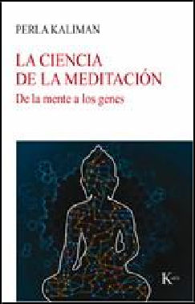

Editorial Kairos 9788499885780
Pub Date: 10/1/18
$21.95
Discount Code: LON Trade Paperback
144 Pages
Carton Qty: 56
Body, Mind & Spirit / Mindfulness & Meditation OCC010000
8 in H | 5 in W | 0.5 in T |
0.4 lb Wt

La ciencia de la meditación

De la mente a los genes
Perla Kaliman

Summary Presented by a cutting-edge researcher in the field, La ciencia de la meditación is a fascinating journey through the latest scientific discoveries about the risks of chronic stress and the benefits of meditative practice, which range from brain health to epigenetics.
Contributor Bio Perla Kaliman is a biochemist and researcher at the Center for Mind and Brain at the University of California–Davis and a collaborator at the Center for Healthy Minds at the University of Wisconsin–Madison.
She has published numerous research articles and is the coauthor of Epigenetics of Lifestyle and Cocina para tu mente.

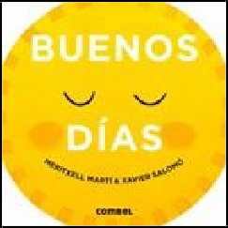

Combel Editorial 9788491012504
Pub Date: 10/1/18
$15.95
Discount Code: LON Hardcover
16 Pages
Carton Qty: 40
Ages 0 to 3, Grades P And Under
Juvenile Fiction / Health & Daily Living
JUV015010
Series: Día y noche
6.8 in H | 6.8 in W | 0.8 in T
| 0.6 lb Wt

Buenos días
Meritxell Martí, Xavier Salomó

Summary This cardboard book teaches children different daily activities and routines. With illustrations by the renowned Xavier Salomo, the interactive pages will captivate young readers as they lift the tabs up and down to wake all the characters up and then put them to bed.
Contributor Bio Meritxell Marti is a writer and professor of art and literature at the Open University of Catalonia. He received his bachelors and PhD in humanities from the Independent University of Barcelona. He has published over thirty children's books. Xavier Salomó is an award-winning illustrator of children’s books. They previously collaborated on 10 ciudades y 1 sueño, 10 viajes y un sueño, and Una noche bestial.

IPG

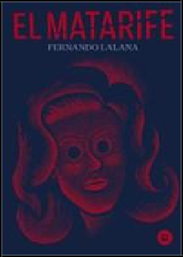

Bambú 9788483435137
Pub Date: 10/1/18
$13.95/€17.70 EU
Discount Code: LON Trade Paperback
256 Pages
Carton Qty: 30
Ages 12 And Up, Grades 7 And Up
Young Adult Fiction / Horror YAF026000
Series: EXIT
8.5 in H | 6 in W

El Matarife
Fernando Lalana

Summary Past and present intermix in this intriguing novel in which a murderer remembers from jail the crimes he committed when he was young. In the past, the Zaragosa police follow the trail of a serial killer who removes the eyes of his victims. At the head of the investigation is German Goitia, a young policeman with a dark past. As he tracks the first serial killer of his career, Goitia uncovers secrets that might prevent him from investigating a killer ever again.
Contributor Bio Fernando Lalana is the recipient of the Cervantes Chico award and the Premio Nacional de Literatura Infantil y Juvenil, awarded by Spain’s Ministry of Culture. He is the author of more than 80 children’s and young adult books, including Almogávar sin querer, Industrias Gon, and Mande su hijo a Marte, as well as of four other books in the EXIT series: Amsterdam Solitaire, El asunto Galindo, La tuneladora, and El último muerto.

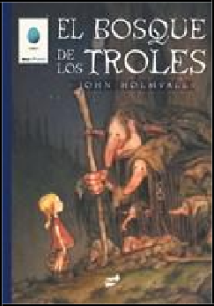

Thule Ediciones 9788416817153
Pub Date: 10/1/18
$14.95/€22.00 EU
Discount Code: LON Hardcover
60 Pages
Carton Qty: 25
Ages 9 to 12, Grades 4 to 7 Juvenile Fiction / Comics & Graphic Novels
JUV008070
9.8 in H | 7 in W | 0.4 in T |
0.8 lb Wt

El bosque de los troles
John Holmvall

Summary John Holmvall gives new life to characters of Nordic folk tales such as fairies, witches, and trolls. The illustrations throughout this book are inspired by the prestigious Jon Bauer, who passed his expertise along to a generation of Nordic illustrators.

Contributor Bio
John Holmvall is an author of fairy tales. El bosque de los troles is his first book.

IPG

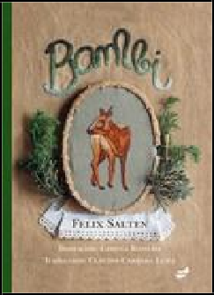

Thule Ediciones 9788416817016
Pub Date: 10/1/18
$24.95
Discount Code: LON Hardcover
224 Pages
Carton Qty: 24
Ages 7 to 9, Grades 2 to 4 Juvenile Fiction / Classics JUV007000
9 in H | 6.5 in W | 0.9 in T |
1.5 lb Wt

Bambi
Felix Salten, Gimena Romero

Summary Bambi comes into the world between the caresses of his mother, full of innocence. He does not know about the danger of the meadow; the inhabitants of the forest; the chattering magpie; the screaming jays; the flying flowers; or the leaping weeds. Neither do his friends Gobo and Falina. Nor do they know about Him, the hunter. A novel about the adventures of growing up, this story also looks at the relationships between humans and animals.
Contributor Bio Felix Salten is an Austrian writer known around the world primarily for his book Bambi, though his work is actually quite diverse. He published a variety of plays, novels, essays, travel books, and film scripts. Gimena Romero is an artist and illustrator who specializes in textile graphics. She received a degree in visual and plastic arts from the National Institute of Fine Arts.

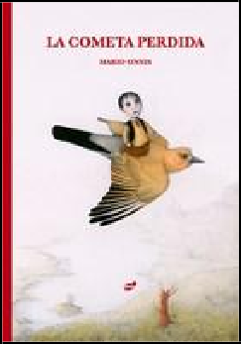

Thule Ediciones 9788416817191
Pub Date: 10/1/18
$16.95
Discount Code: LON Hardcover
40 Pages
Carton Qty: 25
Ages 5 to 7, Grades K to 2 Juvenile Fiction / Social Themes
JUV039060
11.8 in H | 8.3 in W | 0.4 in T | 1 lb Wt

La cometa perdida
Mario Onnis

Summary Nino’s favorite activity is flying a kite, but one day is escapes from his grip. He asks an old tree, a fish, his neighbor, and a bee for help. Finally, a bird gives him a clue and takes him up into the clouds, where he finds a wounded dragon using his kite to fix his broken wing. This book is a heartwarming story about friendship.
Contributor Bio Mario Onnis studied language and illustration where he specialized in children’s editorial illustration. After obtaining his master’s, thus began his journey into the world of illustration.

IPG

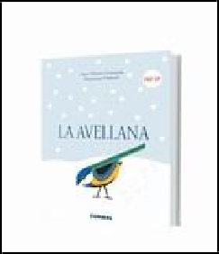

Combel Editorial 9788491012825
Pub Date: 10/1/18
$19.95
Discount Code: LON Hardcover
16 Pages
Carton Qty: 50
Ages 0 to 3, Grades P And Under
Juvenile Nonfiction / Concepts
JNF013090
Series: Libros para curiosear
6.3 in H | 8.3 in W | 0.8 in T
| 0.6 lb Wt

La avellana
Anne Florence Lemasson

Summary
Winter arrived. Page after page, the snow covers the small hazelnut that the squirrel left behind, forgotten. Other animals venture into the garden until spring arrives once again. This story combines text with poetic images about the cycle of life and the passage of time.
Contributor Bio Anne-Florence Lemasson studied literature at the Sorbonne in Paris, and currently is a secondary school teacher. Dominique Ehrhard is an illustrator and shares her passion for books with the author.

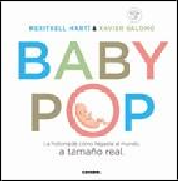

Combel Editorial 9788491012740
Pub Date: 10/1/18
$23.95
Discount Code: LON Hardcover
18 Pages
Carton Qty: 12
Ages 0 to 3, Grades P And Under
Juvenile Nonfiction / Family JNF019040
Series: Minipops
10.3 in H | 10.3 in W | 0.6 in T | 1.3 lb Wt

Baby-pop
Meritxell Martí

Summary Children often wonder what they were like when they grew up in their mother’s womb. Discover the magic and beauty of the beginning of life in nine three-dimensional illustrations of a baby in real size, month by month. This book is a great way to explain to children how their life was in their mother’s womb and is the perfect gift for the arrival of a new baby.
Contributor Bio Meritxell Martí is an artist, a composer, a musician, an award-winning author of more than 30 books and an art and literature professor. She is the author of La isla de las 160 diferencias and Me llamo Mozart among many others.

IPG

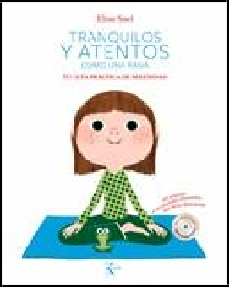

Editorial Kairos 9788499886299
Pub Date: 10/1/18
$29.95
Discount Code: LON Trade Paperback
104 Pages
includesaudiocd 1
Carton Qty: 14
Family & Relationships / Parenting
FAM034000
10.8 in H | 8.5 in W | 0.4 in T | 1.1 lb Wt

Tranquilos y atentos como una rana. Tu guía práctica de serenidad
Eline Snel

Summary Children who suffer from restlessness and stress, either at home or at school, will greatly benefit from this simple yet effective mindfulness guide. Specially addressed to children ages 5 through 10, it includes 80 playful activities to learn how to achieve calmness and mindfulness. It is a resource that has the power to help children be attentive to their bodies and emotions, open up to others, and grow into mindful adults.
Contributor Bio Eline Snel is a therapist and trainer who has developed a successful meditation method for children and teenagers. She facilitates training courses on mindfulness to teachers, psychologists, parents, and children.
She is the author of the international bestseller Breathe Through This: Mindfulness for Parents of Teenagers.

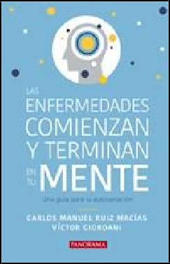

Nostra Ediciones 9786078469451
Pub Date: 10/1/18
$13.95
Discount Code: LON Trade Paperback
144 Pages
Carton Qty: 70
Self-Help / Personal Growth SEL031000
8.3 in H | 5.3 in W | 0.4 in T
| 0.3 lb Wt

Las enfermedades comienzan y terminan en tu mente

Una guía para la autosanación
Carlos Manuel Ruiz Macías, Víctor Giordani

Summary Advances in knowledge admit that an altered emotional state can lead to illness. This guide to self-healing provides all the information and insight necessary to understand how illnesses can be the result of pernicious thoughts and feelings. It teaches readers that creating a set of mental, spiritual, and emotional conditions that are optimal and balanced is the key to achieving and maintaining health.
Contributor Bio
Carlos Manuel Ruiz Macías is a neurosurgeon and a researcher on brain and nervous system function. Víctor Giordani is a writer, lecturer, and psychologist with a PhD on metaphysics and clinical hypnosis. He is a pioneer on the use of hypnosis to maximize excellence in business and sales. He is the author of Las 5 leyes para lograrlo todo.

IPG

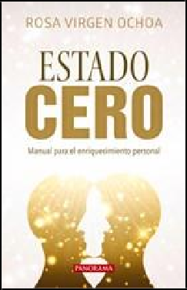

Nostra Ediciones 9786078469444
Pub Date: 10/1/18
$14.95
Discount Code: LON Trade Paperback
168 Pages
Carton Qty: 40
Self-Help / Personal Growth SEL031000
8.3 in H | 5.3 in W | 0.5 in T
| 0.4 lb Wt

Estado cero

Manual para el enriquecimiento personal
Rosa Virgen Ochoa

Summary Readers who feel overwhelmed by conflict and fear they are missing out on their potential will greatly benefit from this book. It is a handbook for personal development that introduces a comprehensive methodology for reaching the highest degree of fulfillment, or “zero state.” It draws on the key principles from psychology, neuroscience, metaphysics, and Buddhist philosophy to help readers achieve the physical, emotional, and mental balance they long for.
Contributor Bio Rosa Virgen Ochoa is a psychologist and life coach, with extensive training in cosmobiology, neuroscience, and dream interpretation. Her work also integrates holistic techniques including Buddhist philosophies, metaphysics, theology, and various energetic therapies. She leads her own training center where she helps people make positive changes to improve their lives.

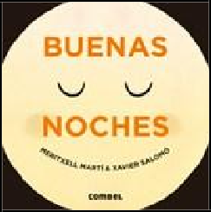

Combel Editorial 9788491012528
Pub Date: 10/1/18
$15.95
Discount Code: LON Hardcover
16 Pages
Carton Qty: 40
Ages 0 to 3, Grades P And Under
Juvenile Fiction / Bedtime & Dreams
JUV010000
Series: Día y noche
6.8 in H | 6.8 in W

Buenas noches
Meritxell Martí, Xavier Salomó

Summary At nightfall, the moon comes to inspire our dreams. Shh! You have to go to sleep! This board book will help little ones learn bedtime routines. With illustrations by renowned illustrator Xavier Salomó, this book will captivate little ones when their fingers slide the tabs down so that everyone goes to sleep.
Contributor Bio Meritxell Marti is a writer and professor of art and literature at the Open University of Catalonia. He received his bachelors and PhD in humanities from the Independent University of Barcelona. He has published over thirty children's books. Xavier Salomó is an award-winning illustrator of children’s books. They previously collaborated on 10 ciudades y 1 sueño, 10 viajes y un sueño, and Una noche bestial.

IPG

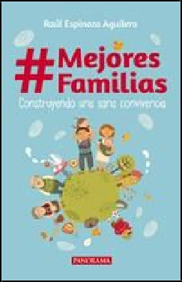

Nostra Ediciones 9786078469376
Pub Date: 10/1/18
$14.95
Discount Code: LON Trade Paperback
168 Pages
Carton Qty: 68
Family & Relationships / Conflict Resolution FAM013000
8.3 in H | 5.3 in W | 0.5 in T
| 0.4 lb Wt

#Mejores Familias

Construyendo una sana convivencia
Raul Espinoza Aguilera

Summary The ways in which couples and children relate to one another have undergone significant changes in recent times. But this insightful book suggests that the essence of these relationships is still intact. With anecdotes from his own childhood and practical advice on how to better live together, the author argues that the family is the fundamental social unit, and that no less than the future of humanity rests on its shoulders.
Contributor Bio Raúl Espinoza Aguilera is an established journalist and writer. He has worked in the publishing industry and his writing has been featured in various media outlets. His books include Si quieres puedes ser feliz and Cómo fomentar el amor en la familia.

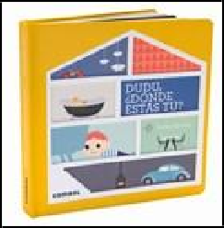

Combel Editorial 9788491012788
Pub Date: 10/1/18
$14.95
Discount Code: LON Hardcover
20 Pages
Carton Qty: 20
Ages 3 to 5, Grades P to K Juvenile Fiction / Interactive Adventures JUV020000
7.3 in H | 7.3 in W | 0.9 in T
| 0.7 lb Wt

Dudú, ¿dónde estás tú?
Lorea De Vos

Summary Leo has lost his doll and he’s sure that he left it at the entrance of the house, but no, it’s not there. Maybe the dining room? Or perhaps the bathroom? Where could it be? This board book is a tour of the house—room by room— as the reader searches with Leo for his doll.
Contributor Bio Lorea De Vos is a director of 3D illustration and independent art. She is also the author of the children’s books Marcel y Joachim.

IPG

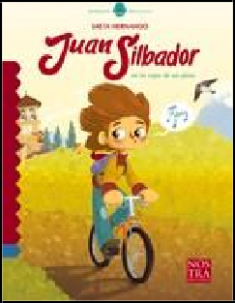

Nostra Ediciones 9786078469437
Pub Date: 10/1/18
$11.00
Discount Code: LON Trade Paperback
48 Pages
Carton Qty: 70
Ages 7 to 9, Grades 2 to 4 Juvenile Fiction / Nature & The Natural World JUV029010
8 in H | 6 in W | 0.2 in T |
  - lb Wt

Juan Silbador en la copa de un pino
Saeta Hernando

Summary In this moving story on the importance of heartfelt decisions, readers get to meet Juan Silbador. He is a restless and sickly little boy who learns how to whistle, a skill that will prove to change his life. Prompted by his teacher to decide on an occupation for the rest of his life, Juan chooses what makes him truly happy. The book includes a guide to regional birds from the American continent.

Contributor Bio
Hernando Saeta is a writer, comic book author, and illustrator.

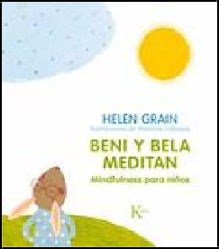

Editorial Kairos 9788499886268
Pub Date: 10/1/18
$21.95
Discount Code: LON Trade Paperback
48 Pages
Carton Qty: 16
Family & Relationships / Parenting
FAM034000
10 in H | 8.8 in W | 0.5 in T
| 1 lb Wt

Beni y Bela meditan

Mindfulness para niños
Helen Grain

Summary A family of rabbits walk readers through the practice of mindfulness in this hands-on resource. With special emphasis on paying attention to the body, enjoying small things, minding the breath, and engaging all five senses at meals, the book provides effective mindfulness techniques and tools for children. These have the power to help them cope with stress and avoid anxiety or anguish.
Contributor Bio Helen Grain is a mindfulness trainer and the founder of Mindfulness 24/7, a training platform teaching courses on meditation, mindfulness-based stress reduction, and mindful leadership. She is also a yoga practitioner, trainer, and the author of Mindfulness, la magia del momento.

IPG

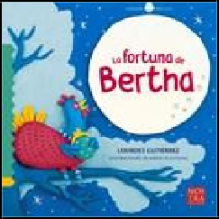

Nostra Ediciones 9786078469413
Pub Date: 10/1/18
$11.00
Discount Code: LON Trade Paperback
36 Pages
Carton Qty: 70
Ages 3 to 5, Grades P to K Juvenile Fiction / Imagination & Play JUV051000
8 in H | 8 in W | 0.1 in T |
  - lb Wt

La fortuna de Bertha
Lourdes Gutierrez, Memo Plastilina

Summary What do a hen and a sky rocket have in common? Young readers of this delightful story will find out when they meet Bertha, a smart hen who has figured out that she will never be able to reach the moon on wishful thinking alone.
Contributor Bio Lourdes Gutiérrez is a teacher and author of children’s literature. A fervent advocate for storytelling, for the past 15 years her work has focused on the promotion of reading among children. She facilitates lectures on this topic to parents and teachers.

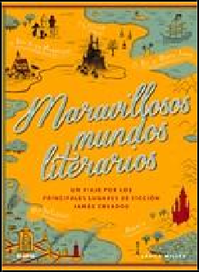

Blume 9788416965694
Pub Date: 10/1/18
$29.95
Discount Code: LON Hardcover
320 Pages
Carton Qty: 12
Fiction / Fairy Tales, Folk Tales, Legends & Mythology FIC010000
9.3 in H | 6.5 in W | 1.3 in T
| 2.2 lb Wt

Maravillosos mundos literarios

Un viaje por los principales lugares de producción jamás creados
Laura Miller

Summary A beautiful volume filled with magical kingdoms, this book is an homage to the marvelous power of the human imagination. Guided by the editorial hand of the journalist and literary critic Laura Miller, this collection of writers and experts delve into the significance of almost a century of wonderful fantasy lands, as well as the time periods in which they were created and the lives of their creators.
Contributor Bio Laura Miller is the co-founder of Salon.com where she has worked as a writer and editor for more than twenty years. She currently has a books and culture column in Slate. Her articles and literary criticism have been published in the New Yorker, Harper's, The Guardian, and The New York Times Book Review.

IPG

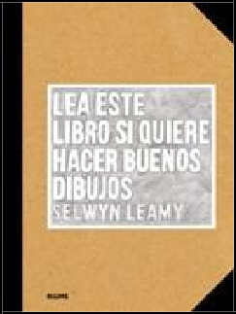

Blume 9788416965625
Pub Date: 10/1/18
$15.95
Discount Code: LON Trade Paperback
128 Pages
Carton Qty: 32 Art / Techniques ART010000
9.5 in H | 7 in W | 0.6 in T | 1 lb Wt

Lea este libro si quiere hacer buenos dibujos
Selwyn Leamy

Summary For anyone who has always wanted to draw but has never known where to begin, this book demystifies all the techniques and processes of drawing and provides everything someone might need to begin drawing the world. It contains diagrams and exercises along with examples from some of the greatest artists in history, such as Picasso and Matisse, to teach the skills needed to draw like a professional.
Contributor Bio Selwyn Leamy is an artist who lives and works in London. He has experience in teaching a broad range of ages and, as a co-founder of the creative travel company Frui, has taught drawing and painting in various locations around the world.

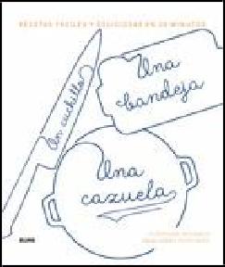
Blume 9788416965854
Pub Date: 10/1/18
$24.95
Discount Code: LON Hardcover
304 Pages
Carton Qty: 8 Cooking / Methods CKB070000
10.3 in H | 8.6 in W | 1.4 in T | 3.2 lb Wt

Un cuchillo, una bandeja, una cazuela

Recetas fáciles y deliciosas en 20 minutos
Stéphane Reynaud

Summary Un cuchillo, una bandeja, una casuella contains 162 simple recipes with great flavor that require no more than 20 minutes in the kitchen. Ideal for beginners or experts who want to eat well using the least effort possible, this cookbook proves that the minimalist kitchen is full of possibilities.
Contributor Bio Stéphane Reynaud is a French chef and cookbook author. The grandson of a village butcher in the Ardèche region in France, Reynaud is the author of Pork & Sons and French Feasts.

IPG

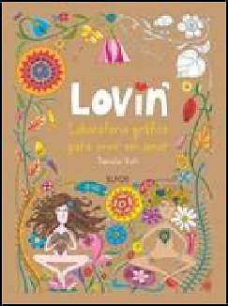

Blume 9788416965427
Pub Date: 10/1/18
$9.95/€12.08 EU
Discount Code: LON Trade Paperback
72 Pages
Carton Qty: 30
Body, Mind & Spirit / Inspiration & Personal Growth
OCC019000
9 in H | 6.5 in W | 0.4 in T |
0.5 lb Wt

Lovin’

Laboratorio gráfico para vivir en amor
Daniela Violi

Summary The result of years of studying love and creativity, this book of coloring exercises created by Daniela Violi inspires self-love and happiness. The activities activate the part of the brain associated with pleasure and wellbeing and thus, little by little, allow those who practice them to take control of their lives and enjoy the present.
Contributor Bio Daniela Violi is an investigator of love in all its forms. She studied science of social communication in Bogota, and learned to make books at the Academy of Fine Art in Carrera, Italy. She hosts a weekly radio program about love and relationships and is the author of Re-enamorarte.

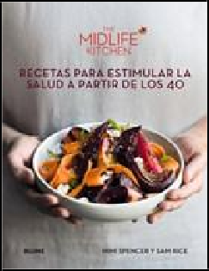

Blume 9788416965762
Pub Date: 10/1/18
$29.95
Discount Code: LON Hardcover
304 Pages
Carton Qty: 10
Cooking / Health & Healing CKB039000
9.8 in H | 7.5 in W | 1.2 in T
| 2.9 lb Wt

The Midlife Kitchen

Recetas para estimular la salud a partir de los 40
Mimi Spencer, Sam Rice's

Summary Middle age is not the time to be preoccupied with the latest diet trends. A busy life requires simple and nutritious recipes. Eat healthy ingredients in delicious combinations with the help of over 150 rejuvenating recipes.
Contributor Bio Mimi Spencer is best known for co-authoring the best-selling book The Fast Diet, which has sold over a million copies worldwide, with Doctor Michael Mosley. She has been a columnist for You Magazine, Observer Food Monthly, and Waitrose Kitchen, while also writing lifestyle, fashion and food features for The Times. Sam Rice decided to overhaul her diet in the interests of living a longer and healthier life. She wrote about the process in her book The Happy Eater: 4 Weeks to a Better Relationship with Food, which was self-published in 2014.

IPG

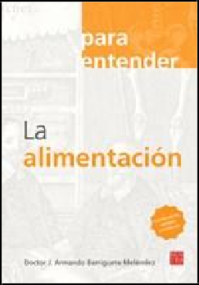

Nostra Ediciones 9786078469321
Pub Date: 10/1/18
$15.95
Discount Code: LON Trade Paperback
136 Pages
Carton Qty: 50
Health & Fitness / Diseases HEA039000
9 in H | 6.3 in W | 0.4 in T |
0.6 lb Wt

La alimentación
J. Armando Barriguete Meléndez

Summary According to research conducted by the World Health Organization, more than 600 million people suffer from high blood pleasure in Western countries. This informative resource provides a guide to the symptoms and complications associated with this widespread condition.
Contributor Bio Doctor J. Armando Barriguete Meléndez is a surgeon and psychoanalyst specialized in eating disorders, obesity, cardiology, and nutrition. He cofounded the first clinic for the treatment of eating disorders in Mexico in 1986. He is the president of the French-Mexican Medical Foundation and was named a knight of the French Legion of Honor.

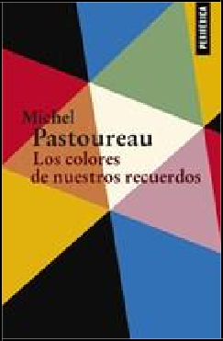

Editorial Periferica 9788416291489
Pub Date: 10/1/18
$22.95/€27.66 EU
Discount Code: LON Trade Paperback
272 Pages
Carton Qty: 30 Philosophy / Essays PHI035000
Series: Fuera de serie
8.5 in H | 5.5 in W | 0.7 in T
| 0.9 lb Wt

Los colores de nuestros recuerdos
Michel Pastoureau

Summary What remains of the colors of our childhoods? What colors do we associate with our adult life? Does memory transform colors? Why? To try to answer these questions, Michel Pastoureau proposes a journey that covers more than the last half century and even leads us to the remote past.
Contributor Bio Michel Pastoureau is a historian and color specialist. He is also the author of Azul, Diccionario de los colores, El oso, and Una historia simbólica de la Edad Media occidental, among many others.

IPG

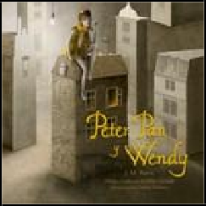

Nostra Ediciones 9786078469406
Pub Date: 10/1/18
$19.00
Discount Code: LON Trade Paperback
240 Pages
Carton Qty: 20
Ages 9 to 12, Grades 4 to 7 Juvenile Fiction / Classics JUV007000
7.8 in H | 7.8 in W | 0.8 in T
| 1.3 lb Wt

Peter Pan y Wendy
J.M. Barrie, Felipe Garrido, Gabriel Pacheco

Summary Peter Pan is not a child like any other. He is a carefree young boy who can fly and refuses to grow up. He lives on the island of Neverland with the merry Lost Boys and the fairy Tinker Bell. When he invites the Darling children to come along on a fantastic trip to his mythical land, fabulous adventures and formidable perils ensue.

Contributor Bio
J.M. Barrie was a Scottish novelist and playwright. A successful writer throughout his life, he is best remembered today as the creator of the beloved Peter Pan and his friends. Felipe Garrido is a prolific and award-winning writer, editor, and translator. His articles and essays have been featured in various media outlets. Gabriel Pacheco is a set designer and illustrator. He studied set design at the National Institute of Fine Arts in Mexico City.

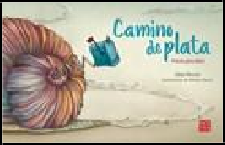
Nostra Ediciones 9786078469420
Pub Date: 10/1/18
$18.00
Discount Code: LON Trade Paperback
128 Pages
Carton Qty: 40
Ages 0 to 3, Grades P And Under
Juvenile Fiction / Poetry JUV070000
7.3 in H | 11.5 in W

Camino de plata

Poesía para niños
Gilda Rincón, Bárbara Sansó

Summary With beautiful illustrations that capture the spirit and voice in each poem, this poetry collection will enthrall young readers of a wide range of ages. The poems, haikus, tongue-twisters, and riddles in this collection invite children to relish in the creative power of lyrical language.
Contributor Bio Gilda Rincón is a prolific poet whose extensive lyrical work has been featured in various literary supplements, anthologies, and books. She has authored the lyrics to many of the children songs by Los Hermanos Rincón. Bárbara Sansó is a book illustrator and graphic designer. She studied fine arts at the University of Barcelona and holds a postgraduate degree in advanced illustration. Las cuatro estaciones and Cuando desapareció el mar are among the many children’s books she has illustrated.

IPG

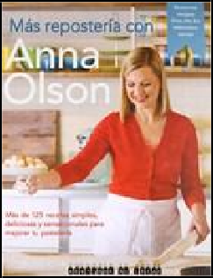

Lectura Colaborativa 9789874095091
Pub Date: 10/1/18
$30.99
Discount Code: LON Trade Paperback
330 Pages
Carton Qty: 14 Cooking / Methods CKB004000
11.5 in H | 8.8 in W

Más repostería con Anna

125 recetas simples y sensacionales
Anna Olson

Summary In her most recent book of sweet recipes, the celebrity chef Anna Olson uncovers the secrets of baking with 125 incredible recipes that originally aired on her tv show Bake. Whether it's a simple recipe for ginger cookies or a much more complicated multi-layer cake, Más repostería con Anna provides all the tips and tricks necessary to successfully make all her tasty creations.
Contributor Bio Anna Olson is a professional trained pastry chef with a degree in culinary arts from Johnson & Wales University. She currently hosts Bake with Anna Olson which airs on Food Network Canada. She is also the author of In the Kitchen with Anna, Another Cup of Sugar, Fresh with Anna Olson, and many others.

