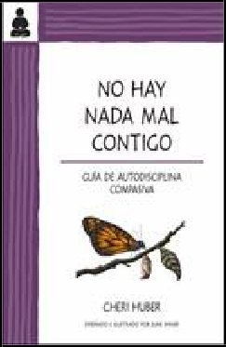

Keep It Simple Books 9780991596348
Pub Date: 9/7/18
On Sale Date: 9/7/18 Ship Date: 10/1/17
$12.95/$14.95 Can.
Discount Code: LON Trade Paperback
300 Pages
Carton Qty: 40 Religion / Buddhism REL092000
8.5 in H | 5.5 in W

No hay nada mal contigo

Guía de autodisciplina compasiva
Cheri Huber

Summary This book reveals the origin of self-hate, how self-hate works, how to identify it, and how to go beyond it. It provides examples of some of the forms self-hate takes, including taking blame but not credit, holding grudges, and trying to be perfect, and explores the many facets of self-hate, including its role in addiction, the battering cycle, and the illusion of control. After addressing these factors, it illustrates how a meditation practice can be developed and practiced in efforts to free oneself from self-hating beliefs.
Contributor Bio Cheri Huber has been a student and teacher of Zen for over 35 years and is the founder of the Zen Monastery Peace Center and Living Compassion, a nonprofit dedicated to peace and service. She is also the author of 20 books including The Big Bamboozle and What You Practice Is What You Have.

IPG

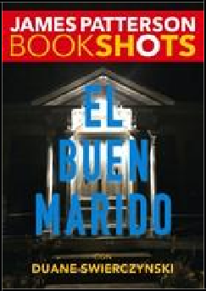

Editorial Oceano de Mexico 9786075274560
Pub Date: 9/1/18
$6.95
Discount Code: LON Trade Paperback
152 Pages
Carton Qty: 70 Fiction / Mystery & Detective FIC022000
Series: Bookshots
7 in H | 5 in W | 0.5 in T |
0.3 lb Wt

El buen marido
James Patterson, Duane Swierczynski

Summary Harry Posehn seems to be a great father and a loving husband, but maybe he isn’t. Detective Teaghan Beaumont is getting closer and closer to discovering the truth about Mr. Posehn, but there is a twist that not even she can see coming.
Contributor Bio James Patterson has written more bestsellers and created more enduring fictional characters than any other novelist writing today. He lives in Florida with his family. Duane Swierczynski is an American crime writer who has written many non-fiction books, novels and comic books.

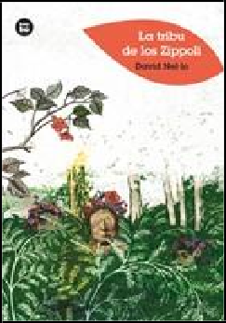

Bambú 9788483435113
Pub Date: 9/1/18
$9.95/€13.21 EU
Discount Code: LON Trade Paperback
144 Pages
Carton Qty: 52
Ages 9 to 12, Grades 4 to 7 Juvenile Fiction / Action & Adventure
JUV001000
Series: Jóvenes lectores
8.3 in H | 5.8 in W | 0.4 in T
| 0.5 lb Wt

La Tribu de los Zippoli
David Nel·lo

Summary In La Tribu de los Zippoli, Guillermo comes from a family of great readers, but he doesn't like to read. It's too difficult, so he gets bored and stops. However, at school, Guillermo finds a magical book in the library that changes its story with each person who reads it. Thanks to this book, Guillermo grows confident in his ability and discovers the pleasure of reading.
Contributor Bio David Nel·lo is a well-known writer and translator of children's literature. He has been presented with several Spanish national awards for children's literature, including the Barco de Vapor, the Enric Valor de narrative juvenil, and the Columna Jove y Edebe.

IPG

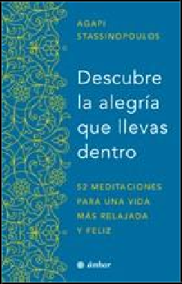

Editorial Oceano de Mexico 9786075273020
Pub Date: 9/1/18
$15.95
Discount Code: LON Trade Paperback
368 Pages
Carton Qty: 24
Body, Mind & Spirit / Inspiration & Personal Growth
OCC019000
9.3 in H | 6.3 in W | 0.9 in T
| 0.8 lb Wt

Descubre la alegría que llevas dentro.

52 meditaciones para una vida más relajada y feliz
Agapi Stassinopoulos

Summary This is the year for self-discovery. Agapi Stassinopoulos uses her years of experience and inspiring wisdom to guide readers through 52 meditations—one for each week of the year. These meditations concentrate on the basic aspects of mindfulness and self-care, enabling those who practice them to discover their full potential and embark on their own personal journey. Readers can learn confidence and discover the joy of finding themselves.
Contributor Bio Agapi Stassinopoulos trained at the Royal Academy of Dramatic Arts in London, and then travelled to the United States to begin her acting career. Much later she earned her master’s degree in psychology from the University of Santa Monica. She is currently a blogger for the Huffington Post

Editorial Oceano de Mexico 9786075273709
Pub Date: 9/1/18
$12.95
Discount Code: LON Trade Paperback
360 Pages
Carton Qty: 36
Self-Help / Personal Growth SEL031000
9.3 in H | 6.3 in W | 0.6 in T
| 0.5 lb Wt

El don de la ira
Arun Gandhi Manilal

Summary Arun Gandhi was only twelve years old when his parents left him in the care of his grandfather. For Arun, the man was just another family member, but the time he spent with Gandhi was one of self-discovery and timeless teachings about identity, anger, unity, and peace. El don de la ira relates the daily life of the most famous and most beloved Indian philosopher through the eyes of a child.
Contributor Bio Arun Gandhi Milal was a journalist for the Times of India for more than thirty years. He currently presides over the M.K. Gandhi Institute for Nonviolence and travels throughout the world hosting conferences for everyone from prominent government leaders to college students. He lives in Rochester, New York.

IPG

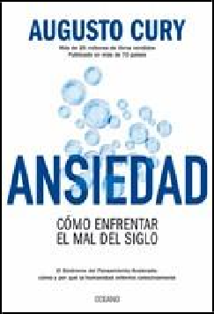

Editorial Oceano de Mexico 9786075274959
Pub Date: 9/1/18
$11.95
Discount Code: LON Trade Paperback
172 Pages
Carton Qty: 48
Self-Help / Anxieties & Phobias
SEL036000
9.3 in H | 6.3 in W | 0.5 in T
| 0.5 lb Wt

Ansiedad

Cómo enfrentar el mal del siglo
Augusto Cury

Summary From childhood to old age, everyone is confronted by anxious thoughts. In Ansiedad, the well-known psychotherapist Augusto Cury identifies the symptoms and characteristics of Accelerated Thought Syndrome and helps readers navigate through their own minds, recognize their frailties, and take responsibility for their own histories. The book explains the deep roots of bad thought habits and offers techniques to recover emotional and mental tranquility so that readers can begin to fully experience the pleasure of living.
Contributor Bio Augusto Cury is a psychiatrist, investigator, and writer. He designed the Theory of Multi-Focal Intelligence, which outlines the complete process of constructing thoughts and the formation of the "I" as the mental administrator. He manages the Academy of Intelligence in Sao Paulo, and is considered the single best-selling author in Brazil.

Editorial Oceano de Mexico 9786075273150
Pub Date: 9/1/18
$17.95
Discount Code: LON Trade Paperback
416 Pages
Carton Qty: 20 Fiction / Mystery & Detective FIC022050
9.5 in H | 6.5 in W | 1.1 in T
| 1.5 lb Wt

El lado negro de Suecia
John-Henri Holmberg

Summary In this anthology, Joh-Henri Homberg presents a collection of the best crime writers of Sweden, including Stieg Larsson and Eva Gabrielsson, with an introductory essay by himself to provide social and cultural context. These seventeen stories—never published in Spanish— offer a complex picture of the dark side of the Scandinavian nation that is vibrant, diverse, and terrifying.
Contributor Bio John-Henri Holmberg is a writer, editor, critic, and translator. He has been recognized for his translations of Lemony Snicket and Stephen King into Swedish, and for his reviews and studies of science fiction and crime fiction.

IPG

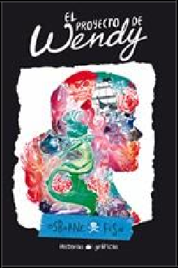

Editorial Oceano de Mexico 9786075271149
Pub Date: 9/1/18
$11.95
Discount Code: LON Trade Paperback
96 Pages
Carton Qty: 36
Ages 12 And Up, Grades 7 And Up
Young Adult Fiction / Comics & Graphic Novels YAF010090
9.3 in H | 6.3 in W | 0.4 in T
| 0.5 lb Wt

El proyecto de Wendy
Veronica Fish, Melissa Jane Osborne

Summary 16-year-old Wendy Davies crashes her car into a lake on a late summer night with her two younger brothers in the backseat. When she wakes in the hospital, she is told that her youngest brother, Michael, is dead.
Wendy ?a once rational teenager– shocks her family by insisting that Michael is alive and in the custody of a mysterious flying boy. Placed in a new school, Wendy negotiates fantasy and reality as students and adults around her resemble characters from Neverland. Given a sketchbook by her therapist, Wendy starts to draw. But is The Wendy Project merely her safe space, or a portal between worlds?
Contributor Bio Veronica Fish is an author and illustrator of graphic novels. She studied at the School of Visual Arts in NYC and at the Massachusetts College of Art and Design in Boston. She has worked as an illustrator for companies such as Marvel Comics and Archie Comics. Melissa Jane Osborne is an actress and writer. She writes scripts for theater and regularly participates in scene festivals.

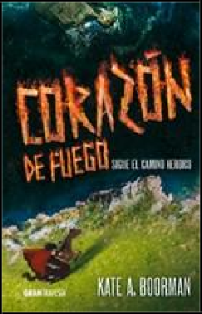

Editorial Oceano de Mexico 9786075271378
Pub Date: 9/1/18
$14.95
Discount Code: LON Trade Paperback
344 Pages
Carton Qty: 24
Ages 12 And Up, Grades 7 And Up
Young Adult Fiction / Science Fiction YAF056000
Series: Invierno asesino
8.8 in H | 5.8 in W | 0.9 in T
| 0.8 lb Wt

Corazon de fuego
Kate A. Boorman

Summary Emmeline and her friends have escaped to the tranquil Matisa valley, but trouble has followed them. The people of Matisa, once protected from predators by a local illness, are now dying in droves, and the attackers won't stay away. Soldiers of the realm are claiming the land for themselves, and in order to recover control and negotiate peace, Emmeline and the people of Matisa must search for a cure. In her dreams, Emmeline imagines running away, never to return, but she is not the frightened girl she once was. Now she will risk her life to assure the future that burns in her heart.
Contributor Bio Kate A. Boorman has a Master of Arts degree from the University of Alberta and has a resume full of an eclectic assortment of jobs. She is also the author of Winterkill.

IPG

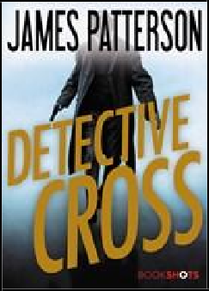

Editorial Oceano de Mexico 9786075274614
Pub Date: 9/1/18
$6.95
Discount Code: LON Trade Paperback
160 Pages
Carton Qty: 52 Fiction / Mystery & Detective FIC022000
Series: Bookshots
6.8 in H | 4.8 in W | 0.5 in T
| 0.3 lb Wt

Detective Cross
James Patterson

Summary
An anonymous caller promises to drop deadly bombs on Washington D.C. Is it a cruel trick or a real threat? By the time Alex Cross and his wife Bree Stone discover the chilling truth, it might already be too late.
Contributor Bio James Patterson has written more bestsellers and created more enduring fictional characters than any other novelist writing today. He lives in Florida with his family.

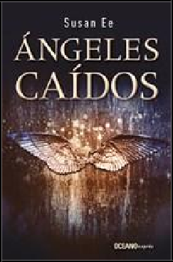
Editorial Oceano de Mexico 9786075274706
Pub Date: 9/1/18
$7.95
Discount Code: LON Mass Market
368 Pages
Carton Qty: 30
Ages 12 And Up, Grades 7 And Up
Young Adult Fiction / Action & Adventure
YAF001000
Series: El fin de los tiempos
7.8 in H | 5 in W | 0.9 in T |
0.6 lb Wt

Ángeles caídos
Susan Ee

Summary During a war between humans and an army of angels, in a world devastated by fear and superstition, warrior angels have stolen a defenseless young girl, but her 17-year-old sister Penryn will do anything to get her sister back.
Contributor Bio Susan Ee loves science fiction, fantasy, and horror, especially if the stories have a touch of romance. A former lawyer, she is now a passionate writer because it gives her imagination free reign. Ángeles caídos is her first novel and the beginning of the El fin de los tiempos trilogy.

IPG

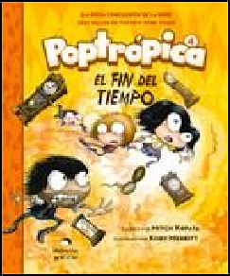

Editorial Oceano de Mexico 9786075273297
Pub Date: 9/1/18
$10.95
Discount Code: LON Trade Paperback
120 Pages
Carton Qty: 40
Ages 7 to 9, Grades 2 to 4 Juvenile Fiction / Comics & Graphic Novels
JUV008000
7.8 in H | 6.3 in W | 0.3 in T
| 0.5 lb Wt

Poptrópica 4
Kory Merritt

Summary In the final installment of Poptrópica, Mya, Oliver, and Jorge are further from home than ever before. With the Aegis destroyed, the islands of Poptrópica have been destabilized, and now there is no way to get across.
However, when all seems lost, the heroes chase a legend about a network in the heart of Poptrópica that connects all of time.
Contributor Bio Kory Merritt is an illustrator and cartoonist who won the John Locher Memorial award in 2007. Inspired by the stories he heard while working at a summer camp, Merritt began a series of children's books called The Lost Side of Suburbia. He is a professor of art in Hammondsport, New York.

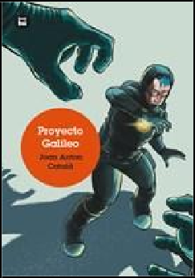

Bambú 9788483435311
Pub Date: 9/1/18
$9.95/€13.21 EU
Discount Code: LON Trade Paperback
264 Pages
Carton Qty: 30
Ages 9 to 12, Grades 4 to 7 Juvenile Fiction / Science & Technology
JUV036000
Series: Jóvenes lectores
8.3 in H | 5.8 in W | 0.7 in T
| 0.9 lb Wt

Proyecto Galileo
Joan Català

Summary Adam Seymour is a high school student in the year 2052. To complete an experiment for school, Adam and his friends sneak onto an expedition to Mars led by Adam's older brother Mike. They are discovered after takeoff, but by then it is too late to go back. When the expedition takes them to trade precious metals on the moon, Adam and his friends will have to help save his brother, and perhaps even Earth itself.
Contributor Bio Joan A. Català has a master’s in both astronomy and astrophysics and collaborates with various media outlets.

IPG

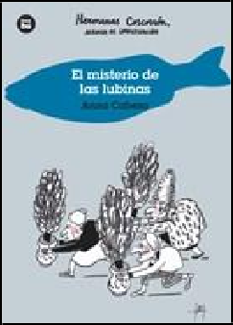

Bambú 9788483435120
Pub Date: 9/1/18
$8.95/€12.24 EU
Discount Code: LON Trade Paperback
96 Pages
Carton Qty: 68
Ages 9 to 12, Grades 4 to 7 Juvenile Fiction / Action & Adventure
JUV001000
Series: Jóvenes lectores
8.3 in H | 5.8 in W | 0.3 in T
| 0.4 lb Wt

El misterio de las lubinas
Anna Cabeza

Summary After the first adventure of the peculiar trio of detectives, Carmen, Rosalia, and Ascension receive a visit from Borja Pijirilis, the manager of the local market. The poor man is desperate to save the market, so the Coscorron accept the case. However, they immediately suspect that beneath his harmless facade, this man is hiding something very complicated and dangerous.

Contributor Bio
Anna Cabeza has a degree in Information Science and a masters in writing for film and television. Throughout her career, she has worked in radio and other Spanish media. She is the author of Quien teme a Pati Perfeta? and Tim, naviz de payaso, and has contributed to several short story anthologies.

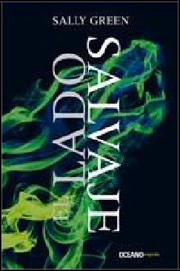

Editorial Oceano de Mexico 9786075274539
Pub Date: 9/1/18
$9.95
Discount Code: LON Mass Market
448 Pages
Carton Qty: 24
Ages 12 And Up, Grades 7 And Up
Young Adult Fiction / Paranormal, Occult & Supernatural YAF045000
Series: Una vida oculta
7.8 in H | 4.8 in W | 1.2 in T
| 0.7 lb Wt

El lado salvaje
Sally Green

Summary Nathan, the protagonist of the first book in this series, El lado oscuro, the extraordinary thriller that captivated thousands of readers, is back! In this sequel we return to Nathan’s struggle to find acceptance among a society of benevolent wizards in spite of his blood ties to evil. Nathan must now fight to reunite with the few allies he has, all the while growing more conscious of the dangerous powers he possesses.
Contributor Bio Sally Green studied literature and creative writing at the Open University in England. She is the author of El lado oscuro.

IPG

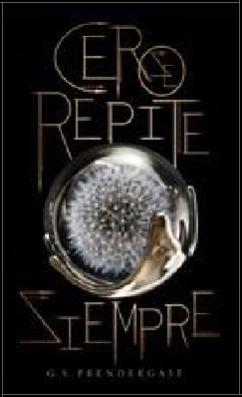

Editorial Oceano de Mexico 9786075274621
Pub Date: 9/1/18
$17.95
Discount Code: LON Trade Paperback
456 Pages
Carton Qty: 20
Ages 12 And Up, Grades 7 And Up
Young Adult Fiction / Science Fiction YAF056010
8.8 in H | 5.8 in W | 1.2 in T
| 1 lb Wt

Cero se repite siempre
Gabrielle S. Prendergast

Summary Eighth is a soldier in the Nahx army with one duty: to protect his partner while she kills the humans. Raven is at summer camp when the Nahx invade and begin to destroy her world. After an alien kills her boyfriend, Raven hides in the forest to avoid suffering the same fate. Eighth and Raven fall prey to hate and fear in the midst of such a violent world, but when Raven is severely injured and Eighth abandons his attack unit, their survival will depend on their ability to trust each other.

Contributor Bio
G. S. Prendergast is a writer, professor, and designer. Author of numerous children's and YA books, she has received multiple awards and nominations for her work.

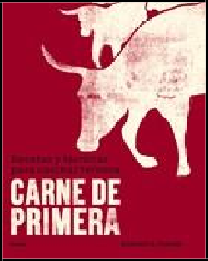
Blume 9788416965342
Pub Date: 9/1/18
$29.95
Discount Code: LON Hardcover
352 Pages
Carton Qty: 10 Cooking / Specific Ingredients CKB054000
10 in H | 7.8 in W | 1.3 in T
| 3 lb Wt

Carne de primera

Recetas y técnicas para cocinar ternera
Richard H. Turner

Summary In Carne de primera, Richard Turner—a master of beef and veal—covers the process of preparing a steak. He shares tips for various types of meat, including seasoning and grilling. He offers advice on how to choose quality meat over quantity, as well as 160 recipes from all corners of the globe.
Contributor Bio Richard H. Turner currently works in the London restaurant scene, from London's celebrated Pitt Cue Co., to Hawksmoor, Foxlow and beyond. He's also one half of the independent butcher and supplier of the
best-quality British rare breed meat money can buy, Turner & George.

IPG

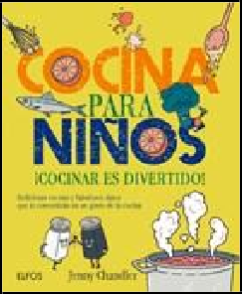

Blume 9788416138883
Pub Date: 9/1/18
$19.95/€24.73 EU
Discount Code: LON Trade Paperback
160 Pages
Carton Qty: 24
Ages 9 to 12, Grades 4 to 7 Juvenile Nonfiction / Cooking & Food
JNF014000
9.3 in H | 7.8 in W | 0.6 in T
| 1.2 lb Wt

Cocina para niños

¡Cocinar es divertido! Deliciosas recetas y fabulosos datos que te convertirán en un genio de la cocina
Jenny Chandler

Summary Cocina para niños contains 50 recipes of both authentic homemade food and exotic dishes from around the world for the whole family to enjoy. The step-by-step pictures, lessons, and instructions will teach kids essential cooking skills that they will use for the rest of their lives.
Contributor Bio Jenny Chandler teaches at various cooking schools in Bristol and London, including her own school, Plum Cooking. She has recently been working for Borough Market with the School Food Matters charity, cooking fruit and vegetables that children have grown in their primary schools. She is the author of The Food of Northern Spain and Pulse.

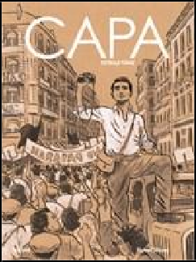

Blume 9788416965168
Pub Date: 9/1/18
$18.95/€24.73 EU
Discount Code: LON Hardcover
88 Pages
Carton Qty: 10
Biography & Autobiography
/ Artists, Architects, Photographers BIO001000
11.8 in H | 8.6 in W | 0.6 in T | 1.7 lb Wt

Capa. Estrella fugaz
Florent Silloray

Summary Robert Capa dedicated his life to capturing all the wars of the world in photographs. This biography tells the legendary story of the prolific photojournalist and immerses us in a unique period of contemporary history.
Contributor Bio Florent Silloray is the illustrator of various French titles, and the author and illustrator of The Book of Roger, a graphic novel adaptation of the memoirs of a soldier who spent World War II in a prison camp.

IPG

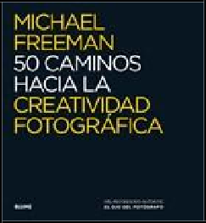

Blume 9788416138876
Pub Date: 9/1/18
$29.95/€35.95 EU
Discount Code: LON Trade Paperback
224 Pages
Carton Qty: 14 Photography / Reference PHO017000
10 in H | 9.3 in W | 0.8 in T
| 2.1 lb Wt

50 caminos hacia la creatividad fotográfica
Michael Freeman

Summary The eagerly awaited follow up to global bestseller The Photographer's Eye reveals the paths the greatest photographers took to excellence. By studying their work, readers can explore 50 "paths" to taking quality photos and developing their own original styles.
Contributor Bio Michael Freeman is a professional photographer and author with 135 book titles to his credit. He received his Master’s in Geography at Brasenose College and Oxford University. Since then, working for editorial clients that include all the world's major magazines, and notably the Smithsonian Magazine, Freeman's reputation has been consolidated as one of the leading reportage photographers.

Blume 9788498018387
Pub Date: 9/1/18
$45.00/€56.98 EU
Discount Code: LON Hardcover
704 Pages
Carton Qty: 4
Biography & Autobiography
/ Composers & Musicians BIO004000
10.5 in H | 8.3 in W | 2.5 in T | 6.1 lb Wt

Bob Dylan

Todas sus canciones
Jean-Michel Guesdon, Philippe Margotin

Summary For the last 50 years, Dylan has been considered one of the most influential musicians in the world, and now stories of all the recording sessions, albums, and singles Bob Dylan released over the course of his illustrious career have been compiled into one volume. Stuffed with photographs and a complete view of Dylan's creative process, this book has everything that a true fan of Dylan could want.
Contributor Bio Jean-Michel Guesdon is a composer, musician, sound engineer, and producer. His talent gives him a unique perspective on the work of Bob Dylan. Philippe Margotin has written several books on musicians, including the biographies of U2, Radiohead, and The Rolling Stones.

IPG

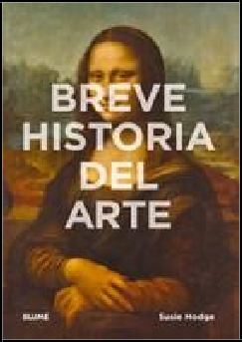

Blume 9788416965021
Pub Date: 9/1/18
$16.95/€21.91 EU
Discount Code: LON Trade Paperback
224 Pages
Carton Qty: 28 Art / History ART015000
8.3 in H | 5.8 in W | 0.8 in T
| 1.2 lb Wt

Breve historia del arte
Susie Hodge

Summary This pocket guide to the fundamental movements, themes, and techniques of Western art is accessible, concise, and stuffed with illustrations. Including an introduction on the most important artistic contributions, from the cave paintings in Lascaux to contemporary installations, this book demystifies the artistic jargon and provides readers with both an understanding and enjoyment of art.
Contributor Bio Susie Hodge is an art historian and artist. She is the bestselling author of numerous books, among them 50 Art Ideas, How to Survive Modern Art, Why Your Five-Year-Old Could Not Have Done That: Modern Art Explained, and 50 Art Nouveau Works of Art You Should Know.

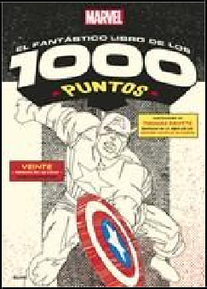
Blume 9788498019612
Pub Date: 9/1/18
$11.95/€17.70 EU
Discount Code: LON Trade Paperback
48 Pages
Carton Qty: 36 Games & Activities / Activity Books GAM020000
Series: unir los 1000 puntos
14 in H | 10 in W | 0.3 in T |
0.9 lb Wt

Marvel el fantástico libro de los 1000 puntos
Thomas Pavitte

Summary Thomas Pavitte combines the fun of connect-the-dots with the thrill of the best comic book characters. Get ready to draw 19 Marvel superheroes, plus an additional image of a confrontation between Iron Man and Captain America composed of 1,700 dots.
Contributor Bio Thomas Pavitte is the bestselling author and creator of the 1000 dot-to-dot series, Querkles and Spiroglyphics. His unique style, when combined with iconic subjects, results in images that are cool enough to put on your wall.

IPG

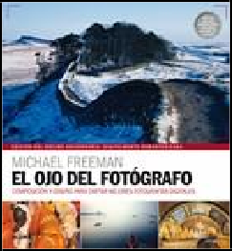

Blume 9788416965328
Pub Date: 9/1/18
$29.95/€35.95 EU
Discount Code: LON Trade Paperback
192 Pages
Carton Qty: 20 Photography / Techniques PHO018000
10 in H | 9.3 in W | 0.7 in T
| 1.8 lb Wt

El ojo del fotógrafo
Michael Freeman

Summary Design, the ability to see the potential for a good picture and then organize the graphic elements into a compelling composition, is the single most important factor in creating a successful photograph. Of course, digital photography has brought a new aspect to design which allows artists to alter and enhance design after they press the shutter. El ojo del fotógrafo shows how anyone can develop an eye for seeing great digital photos.
Contributor Bio Michael Freeman is a professional photographer and author with 135 book titles to his credit. He received his Master’s in Geography at Brasenose College and Oxford University. Since then, working for editorial clients that include all the world's major magazines, and notably the Smithsonian Magazine, Freeman's reputation has been consolidated as one of the leading reportage photographers.

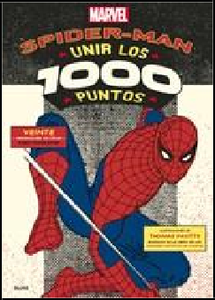
Blume 9788498019629
Pub Date: 9/1/18
$11.95/€17.70 EU
Discount Code: LON Trade Paperback
48 Pages
Carton Qty: 36 Games & Activities / Activity Books GAM020000
14 in H | 10 in W | 0.3 in T |
0.9 lb Wt

Marvel Spiderman

Unir los 1000 puntos
Thomas Pavitte

Summary With 20 complex puzzles to complete, each consisting of at least 1,000 dots and including an epic fight scene with over 1,500 dots to join, web-heads will have hours of fun bringing Spidey's friends, allies and most villainous foes to life.
Contributor Bio Thomas Pavitte is the bestselling author and creator of the 1000 dot-to-dot series, Querkles and Spiroglyphics. His unique style, when combined with iconic subjects, results in images that are cool enough to put on your wall.

IPG

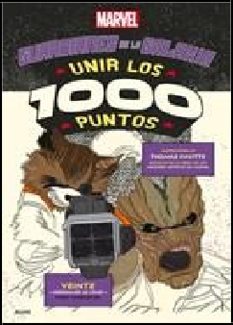

Blume 9788416965229
Pub Date: 9/1/18
$11.95/€17.70 EU
Discount Code: LON Trade Paperback
48 Pages
Carton Qty: 36 Games & Activities / Activity Books GAM020000
Series: unir los 1000 puntos
14 in H | 10 in W | 0.3 in T |
0.9 lb Wt

Marvel Guardianes de la Galaxia

Unir los 1000 puntos
Thomas Pavitte

Summary There are 20 complex puzzles to complete, each consisting of at least 1,000 dots and including an epic match up with over 1,500! Fans of Rocket Racoon, Groot, Star-Lord and the rest of the team will find hours of thrilling fun bringing the Guardians and their foes to life.
Contributor Bio Thomas Pavitte is the bestselling author and creator of the 1000 dot-to-dot series, Querkles and Spiroglyphics. His unique style, when combined with iconic subjects, results in images that are cool enough to put on your wall.

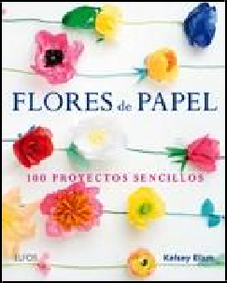

Blume 9788416138913
Pub Date: 9/1/18
$16.95/€24.73 EU
Discount Code: LON Trade Paperback
192 Pages
Carton Qty: 20
Crafts & Hobbies / Flower Arranging
CRA010000
9.8 in H | 7.8 in W | 0.7 in T
| 1.5 lb Wt

Flores de Papel

100 proyectos sencillos
Kelsey Elam

Summary Paper flower arrangements are the perfect decoration for any occasion, whether it's adding a touch of color to a dining room table or creating a winter wedding bouquet, and they never go out of season. Choose from more than 100 models and follow the step-by-step instructions to create every kind of paper flower.
Contributor Bio Kelsey Elam is a florist, craft enthusiast, paper artist, and the director of Moon Flora. She draws her inspiration from the magic of the American Midwest, applying a spectacular array of colors and natural details. She was nominated for the Martha Stewart American Made award in 2014.

IPG

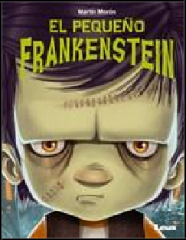

Ediciones Lea 9789877184747
Pub Date: 9/1/18
$19.95
Discount Code: LON Hardcover
16 Pages
Carton Qty: 28
Ages 7 to 9, Grades 2 to 4 Juvenile Fiction / Classics JUV007000
Series: Mis cuentos
11 in H | 8.3 in W | 0.4 in T
| 0.8 lb Wt

El pequeño Frankenstein
Martín Morón

Summary Little Frankenstein wants to be a boy like any other?alas, he is not. In this moving and fun story, he embarks on the greatest adventure of his life: the road to finding himself. Young readers of this originally-illustrated book will be moved and entertained learning about the emotions, friendships, and talents of one of the most endearing monsters in literature.
Contributor Bio Martín Morón is a professor of visual arts but also a writer and illustrator. He is the author of Blancanieves, Rapunzel, Caperucita Roja, Pequeños dinosaurios, Dinosaurios en colores, and many others.

Ediciones Lea 9789877185010
Pub Date: 9/1/18
$21.99
Discount Code: LON Trade Paperback
384 Pages
Carton Qty: 28 Fiction / Classics FIC004000
Series: Historias y romances
9.3 in H | 6 in W | 0.8 in T | 1 lb Wt

Sensatez y sentimientos
Jane Austen

Summary Marianne Dashwood wears her heart on her sleeve, and when she falls in love with the dashing but unsuitable John Willoughby she ignores her sister Elinor's warning that her impulsive behaviour leaves her open to gossip and innuendo. Meanwhile Elinor, always sensitive to social convention, is struggling to conceal her own romantic disappointment, even from those closest to her. Through their parallel experience of love, and its threatened loss, the sisters learn that, if they are to find personal happiness in a society where status and money govern the rules of love, they must mix sense with sensibility.
Contributor Bio Jane Austen has become one of English literature's most famous women writers. She is also the author of Pride and Prejudice, Mansfield Park, Emma, Persuasion and Northanger Abbey.

IPG

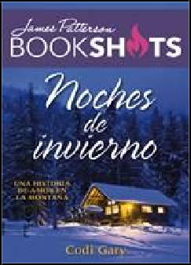

Editorial Oceano de Mexico 9786075274607
Pub Date: 9/1/18
$6.95
Discount Code: LON Trade Paperback
160 Pages
Carton Qty: 56 Fiction / Romance FIC027000
Series: Bookshots
7 in H | 5 in W | 0.5 in T |
0.3 lb Wt

Noches de invierno
James Patterson

Summary Allie Fairchild made a mistake when she moved to Montana. Her rental is a mess, her coworkers at the trauma center are hostile, and her handsome landlord, Dex Belmont, is far from charming. But just when she's about to throw in the towel, life in Bear Mountain takes a surprisingly sexy turn....
Contributor Bio James Patterson has written more bestsellers and created more enduring fictional characters than any other novelist writing today. He lives in Florida with his family. Codi Gary is a romance novelist and lives in Idaho with her family.

Editorial Oceano de Mexico 9786075274911
Pub Date: 9/1/18
$12.95
Discount Code: LON Trade Paperback
216 Pages
Carton Qty: 22
Biography & Autobiography
/ Business BIO003000
9.3 in H | 6.8 in W | 0.6 in T
| 0.6 lb Wt

El camino del lobo
Jordan Belfort

Summary
For the first time ever, Jordan Belfort opens his playbook and gives readers access to his exclusive
step-by-step system—the same system he used to create massive wealth for himself, his clients, and his sales teams. Until now this revolutionary program was only available through Belfort's expensive online training.
Now in El camino del lobo, Belfort is ready to unleash the power of persuasion to a whole new generation of readers, revealing how anyone can bounce back from devastating setbacks, master the art of persuasion, and build wealth. Every technique, every strategy, and every tip has been tested and proven to work in real-life situations.
Contributor Bio Jordan Belfort is a consultant for major business firms and his ideas have been published in newspapers and magazines such as The New York Times, The Wall Street Journal, Los Angeles Times, The Times, Herald Tribune, and many others. He is also the author of The Wolf of Wall Street, which was adapted into film in 2013 with Leonardo DiCaprio as the lead actor.

IPG

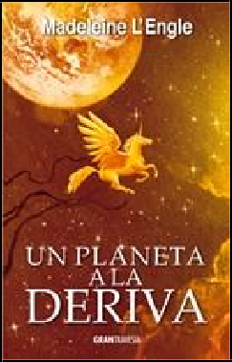

Editorial Oceano de Mexico 9786075274805
Pub Date: 9/1/18
$14.95
Discount Code: LON Trade Paperback
304 Pages
Carton Qty: 28
Ages 12 And Up, Grades 7 And Up
Young Adult Fiction / Classics
YAF009000
8.8 in H | 5.8 in W | 0.8 in T
| 0.7 lb Wt

Un planeta a la deriva
Madeleine L'Engle

Summary In Una planeta a la deriva, fifteen-year-old Charles Wallace and the unicorn Gaudior undertake a perilous journey through time in a desperate attempt to stop the destruction of the world by the mad dictator Madog Branzillo. They are not alone in their quest. Charles Wallace's sister, Meg—grown and expecting her first child, but still able to enter her brother's thoughts and emotions by "kything"—goes with him in spirit. Charles Wallace must face the ultimate test of his faith and his will as he is sent within four people from another time, there to search for a way to avert the tragedy threatening them all.
Contributor Bio Madeleine L'Engle is a popular author of many books for children and adults. She has interspersed her writing and teaching career with raising three children, maintaining an apartment in New York, and a farmhouse called "Crosswicks." Her novel, A Wrinkle in Time, won the Newbery Medal in 1963 and is being adapted into a major motion picture in March 2018.

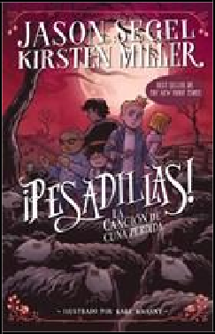

Editorial Oceano de Mexico 9786075271347
Pub Date: 9/1/18
$15.95
Discount Code: LON Trade Paperback
368 Pages
Carton Qty: 24
Ages 9 to 12, Grades 4 to 7 Juvenile Fiction / Monsters JUV052000
Series: ¡Pesadillas!
8.8 in H | 5.8 in W | 1 in T |
0.8 lb Wt

¡Pesadillas! La canción de cuna perdida
Jason Segel, Kirsten Miller

Summary Charlie Laird has a bad feeling. To begin with, a mysterious girl appears at Cypress Creek Elementary School. Then, he begins to hear strange noises very late at night, and the nightmares have returned, crazier than ever. Every time he drifts off to sleep he finds himself surrounded by a flock of creepy black sheep. Could it be that Charlie is trapped in someone else’s nightmares? He isn’t sure, but knows that ICK and INK are responsible.
Contributor Bio Jason Segel is a comedian who is best known for his role in the TV series, How I Met Your Mother. He also played David Foster Wallace in the movie, The End of the Tour. Besides acting, he enjoys writing and composing music. Kirsten Miller is a novelist and the author of the Kiki Strike series. They are co-authors of Nightmares.

IPG

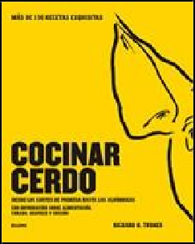

Blume 9788416965359
Pub Date: 9/1/18
$29.95
Discount Code: LON Hardcover
352 Pages
Carton Qty: 10 Cooking / Specific Ingredients CKB054000
10 in H | 8.3 in W | 1.3 in T
| 3 lb Wt

Cocinar cerdo

Más de 150 recetas exquisitas Desde los cortes de primera hasta las albóndigas Con información sobre alimentación, curado, despiece y cocción
Richard H. Turner

Summary Pork is one of the most delicious, popular, and versatile meats in the world, and there are more ways to cook a pig than any other animal. Learn how to find, prepare, cook, and eat the highest quality pork with the help of these 150 recipes.
Contributor Bio Richard H. Turner was classically trained by legendary chefs the Roux brothers, and currently works in the London restaurant scene. He's also partial owner of the independent butcher and supplier of the best-quality British rare-breed meat money can buy, Turner & George.

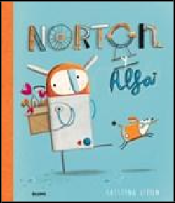

Blume 9788416138944
Pub Date: 9/1/18
$14.95/€17.70 EU
Discount Code: LON Hardcover
32 Pages
Carton Qty: 20
Ages 3 to 5, Grades P to K Juvenile Fiction / Imagination & Play JUV051000
11 in H | 9.3 in W | 0.5 in T
| 1.1 lb Wt

Norton y Alfa
Kristyna Litten

Summary Battered wheels, oxidized gears, broken springs: Norton and Alfa have seen it all, and everything they find always serves a function. Then one day, they find a solitary flower, unlike anything they've ever seen. What is it, and what does it do? Norton y Alfa is an emotional story about friendship, the wonders of nature, and a reminder that there is more to life than meets the eye.
Contributor Bio Kristyna Litten studied Illustration at Edinburgh College of Art. Her first picture book, Flint's Odd Socks, followed by Chickens Can't See in The Dark were nominated for the Macmillan Prize two years running.

IPG

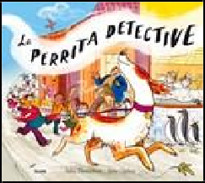

Blume 9788498019568
Pub Date: 9/1/18
$14.95/€17.70 EU
Discount Code: LON Hardcover
32 Pages
Carton Qty: 30
Ages 3 to 5, Grades P to K Juvenile Fiction / Mysteries & Detective Stories JUV028000
9.8 in H | 11 in W | 0.4 in T
| 1 lb Wt

La perrita detective
Julia Donaldson, Sara Ogilvie

Summary Nina, Pedro's puppy, has an extraordinary sense of smell. Whether it's searching for a lost shoe or discovering who has soiled the new gravel road, her valuable nose is always sniffing out something. When she accompanies Pedro to school, they discover that all the school books have disappeared! Who would have taken them, and why? When this mystery needs to be solved, Nina the puppy takes charge of the investigation.
Contributor Bio Julia Donaldson is the prize-winning author of some of the world's best-loved children's books, including modern classics The Gruffalo and The Gruffalo's Child, which together have sold over 17 million copies worldwide. She was Children's Laureate from 2011 to 2013 and has been honored with an MBE for Services to Literature. Sara Ogilvie is an award-winning illustrator and printmaker who won the 2011 Booktrust Best New Illustrator Award. The first picture book that she illustrated, Dogs Don't Do Ballet, was also shortlisted for the Roald Dahl Funny Prize. Sara also lectures in Illustration and Graphic Design at Northumbria University.

Blume 9788498018684
Pub Date: 9/1/18
$22.95/€28.93 EU
Discount Code: LON Trade Paperback
184 Pages
Carton Qty: 20
Design / Graphic Arts DES007000
9.3 in H | 6.5 in W | 0.7 in T
| 1.3 lb Wt

Cómo tener ideas geniales

Guía de pensamiento creativo
John Ingledew

Summary Full of a wide variety of strategies and practical projects for learning how to give form to creative ideas, this is an essential guide for students and young professionals interested in the fields of design, publicity, and communication. Use this book as a practical manual to stimulating creativity and turning inspiration into reality.
Contributor Bio John Ingledew has taught and written about design, photography and creative thinking for 20 years. He has worked at universities all over the world, and recently helped to set up an Art School in Northern China. He currently is a visiting professor at The London School of Film, Media and Design.

IPG

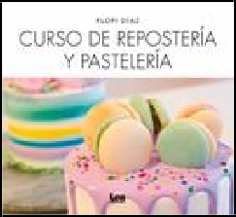

Ediciones Lea 9789877185225
Pub Date: 9/1/18
$16.95
Discount Code: LON Trade Paperback
120 Pages
Carton Qty: 44
Cooking / Courses & Dishes CKB062000
Series: Nueva Cocina
8.8 in H | 8 in W | 0.3 in T |
0.8 lb Wt

Curso de repostería y pastelería
Florencia Diaz

Summary Professional cooks, entrepreneurs, and anybody looking for simple recipes will find what they need in this baking and pastry-making manual. It is equipped with step-by-step directions to prepare baked goods to suit all tastes, from traditional cakes and pies to alfajores. It also provides cake-decorating techniques and a helpful guide to assessing baking costs for those looking to monetize their culinary passion.
Contributor Bio Florencia Díaz studied at the Argentine Institute of Gastronomy and appeared on the television show Súper Dulce. She currently conducts workshops in cooking, baking, and decorating cakes for children and adults.
She is also the author of Popcakes, cupcakes y cookies.

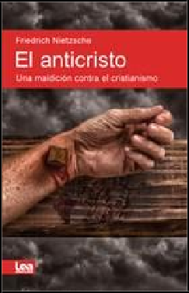

Ediciones Lea 9789877185232
Pub Date: 9/1/18
$12.95
Discount Code: LON Trade Paperback
128 Pages
Carton Qty: 60 Philosophy / Religious PHI022000
Series: Espiritualidad & Pensamiento
9 in H | 6 in W | 0.4 in T |
0.4 lb Wt

El anticristo

Una maldición contra el cristianismo
Friedrich Wilhelm Nietzsche

Summary In El anticristo, Friedrich Niezsche presents his sharpest critique of Judeo-Christian morality. Under attack are compassion, weakness, and the beliefs that came to constitute Western society after the death of Christ, as Niezsche calls for a return to the values of aristocracy—power, force, and the search for truth beyond superstition. Polemical and a little mad, this book of Nietzsche's opened up new paths of thought, some of which have yet to be explored.
Contributor Bio Friedrich Wilhelm Nietzsche is widely regarded as one of the most influential thinkers in Western philosophy. He studied philology, theology, and music, and worked as a professor at the University of Basil.
His controversial oeuvre has contributed to the development of new ways of thinking. Thus Spoke Zarathustra, Beyond Good and Evil, and Twilight of the Idols are among his most prominent books.

IPG

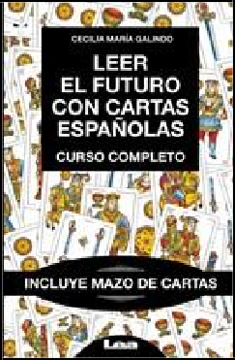

Ediciones Lea 9789877184761
Pub Date: 9/1/18
$36.95
Discount Code: LON Hardcover
160 Pages
Carton Qty: 20
Body, Mind & Spirit / Divination OCC024000
Series: Armonia
9 in H | 6 in W | 1.2 in T | 1 lb Wt

Leer el futuro con cartas españolas (2nd Edition)

Curso Completo
Cecilia María Galindo

Summary Many people are drawn to the possibility of knowing the future through something as simple as a game of cards, yet few possess the skills to do so. This book is a tool for reading and understanding the Spanish tarot deck, useful for beginners as well as those looking to deepen their knowledge of the technique. Its object is not to convert every person into a fortune teller, but rather to teach methods for interpreting the everyday signals that indicate a destiny that can be modified.
Contributor Bio Cecilia María Galindo is a tarot reader, parapsychologist, and specialist in the study of various divination arts. For more than 40 years she has travelled the world learning about the divinatory traditions of different peoples. She is a natural psychic, an expert in home remedies, and a Tibetan Buddhist initiate. She has supplemented her esoteric training with studies in anthropology, theology, numerology, Kabbalah, and history.

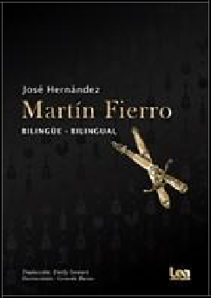

Ediciones Lea 9789877185058
Pub Date: 9/1/18
$28.95
Discount Code: LON Trade Paperback
336 Pages
Carton Qty: 18
Poetry / Caribbean & Latin American
POE012000
9.5 in H | 6.8 in W | 0.7 in T
| 1.5 lb Wt

Martín Fierro

Bilingüe - Bilingual
José Hernandez

Summary José Hernández’s Martín Fierro is considered the foremost work of the gaucho literary genre. The first part, a critique of the Argentine political system, details the persecution of the main character by institutions of power. The second part presents a clear response to the gaucho problem and with it, the reconciliation of civilization in 19th century Argentine society. This book is the national poem of Argentina.
Contributor Bio José Hernandez founded the newspaper El Río de la Plata in Buenos Aires which later would formulate into a verse of Martín Fierro. During his time as a writer, he had a long political career in Argentina.

IPG

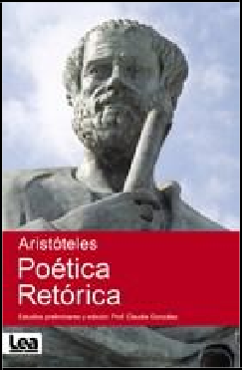

Ediciones Lea 9789877184464
Pub Date: 9/1/18
$19.95
Discount Code: LON Trade Paperback
352 Pages
Carton Qty: 24 Philosophy PHI000000
Series: Espiritualidad & Pensamiento
9 in H | 6 in W | 0.8 in T | 1 lb Wt

Poética. Retórica
Aristotle

Summary Presented here in their entirety, these two fundamental philosophical treatises have deeply influenced the history of human thought, from Ancient Greece up to the present day. They address questions of rhetoric, style, and literary theory that have continued to influence and challenge Western thought for over 2,000 years.
Contributor Bio Aristotle was a prominent ancient Greek philosopher and scientist. He is regarded as one of the greatest thinkers in Western philosophy in the fields of politics, psychology, logic, and ethics. He attended Plato’s academy and was a tutor to Alexander the Great. Politics, Metaphysics, and Nicomachean Ethics are among some of his most notable treatises.

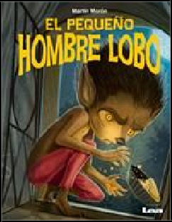

Ediciones Lea 9789877184754
Pub Date: 9/1/18
$19.95
Discount Code: LON Hardcover
16 Pages
Carton Qty: 36
Ages 5 to 7, Grades K to 2 Juvenile Fiction / Classics JUV007000
Series: Mis cuentos
11 in H | 8.3 in W | 0.5 in T
| 0.8 lb Wt

El pequeño hombre lobo
Martín Morón

Summary To his astonishment, Pedro keeps finding his bedroom window open and the room an utter mess night after night. In the kitchen the cookie jar is missing, and heaps of sweets have vanished from the kiosk, so he knows something is up. Brave little boy that he is, Pedro will head to the woods during a full moon, and will find all the answers.
Contributor Bio Martín Morón is a professor of visual arts but also a writer and illustrator. He is the author of Blancanieves, Rapunzel, Caperucita Roja, Pequeños dinosaurios, Dinosaurios en colores, and many others.

IPG

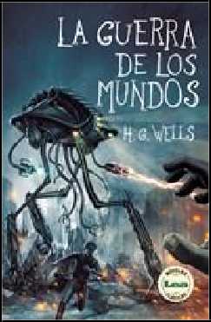

Ediciones Lea 9789877183535
Pub Date: 9/1/18
$15.95
Discount Code: LON Trade Paperback
192 Pages
Carton Qty: 48 Fiction / Satire FIC052000
Series: Novelas Clasicas
9.3 in H | 6 in W | 0.4 in T |
0.6 lb Wt

La guerra de los mundos
Herbert George Wells

Summary An anonymous narrator relates how an attack by vicious Martians is repelled with the aid of humanity’s most unexpected ally. Originally published in 1898, this masterpiece by one of the greatest science fiction writers of all time is not only a fantastic novel?it is also a sharp criticism of Victorian society and its imperialistic ambitions. It is an invitation for contemporary readers to ponder on the fate of our planet.
Contributor Bio Herbert George Wells is a renowned and prolific writer of fiction and nonfiction, historian, journalist, and social critic. Some of his most celebrated novels include The Time Machine, The Island of Doctor Moreau, The Invisible Man, and The War of the Worlds. He was nominated for a Nobel Prize in Literature on four different occasions.

Ediciones Lea 9789877184785
Pub Date: 9/1/18
$16.95
Discount Code: LON Hardcover
160 Pages
Carton Qty: 72
Self-Help / Personal Growth SEL016000
Series: Alternativa
6.8 in H | 4.5 in W | 0.7 in T
| 0.5 lb Wt

Ser feliz es una decisión (2nd Edition) Sutras y enseñanzas del Ayurveda para la vida Fabián Ciarlotti

Summary A sutra—a profound thought compacted into a simple axiom—can be very powerful. A good sutra, such as the ones in this book, is a thought that remains with you and yields a cascade of ideas and thoughts, perhaps even a door to another way of life.
Contributor Bio Fabián Ciarlotti is a doctor and physiotherapist specialized in orthopedic surgery and Ayurvedic medicine, for which he was trained in India. He is a professor at the University of Buenos Aires and at Maimonides University. He is the author of many books, including Traumatología kinésica, Zapping demente, and Ayurveda y Filosofía.

IPG

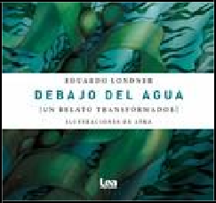

Ediciones Lea 9789877185270
Pub Date: 9/1/18
$11.95
Discount Code: LON Trade Paperback
72 Pages
Carton Qty: 100 Fiction / Fantasy FIC009000
Series: Alternativa
6.5 in H | 6.8 in W | 0.2 in T
| 0.3 lb Wt

Debajo del agua
Eduardo Londner

Summary Without looking for answers or weaving false conclusions, Eduardo Londner submerges the reader in a dream that has the intrinsic characteristics of being awake. This book takes the reader into the unknown, to explore conflicting emotions and to discover how difficult it is not to surrender to the currents of the sea of life.
Contributor Bio Eduardo Londner is a peace ambassador for the foundation A Thousand Miles for Peace, and he spends him time learning internal arts such as yoga or Tai Chi Chuan or water sports like diving and kayaking. He also runs a radio program called The Positive Hour and writes a monthly column in the magazines Uno Mismo and Yoga.

